Solar Cell Appendix
Power Meter
A power meter is a circuit that measures simultaneously both the voltage across and the current through a pair of wires. The circuit multiples the values of voltage and current and produces a product, which is the power flowing through this pair of wires (P = V*I). Figure A.1 shows the structure of the power meter.

Figure A.1 Power meter functional diagram. The power meter consists of circuitry, which measures the voltage across and the current through a pair of wires, multiplies them together, and then displays the instantaneous power.
Figure A.2 shows the top view of the power meter that will be used in this lab. The meter is built on a printed circuit board (PCB). This power meter measures voltage (V) in volts, current (I) in milliamps, and calculates the power (P) in watts.
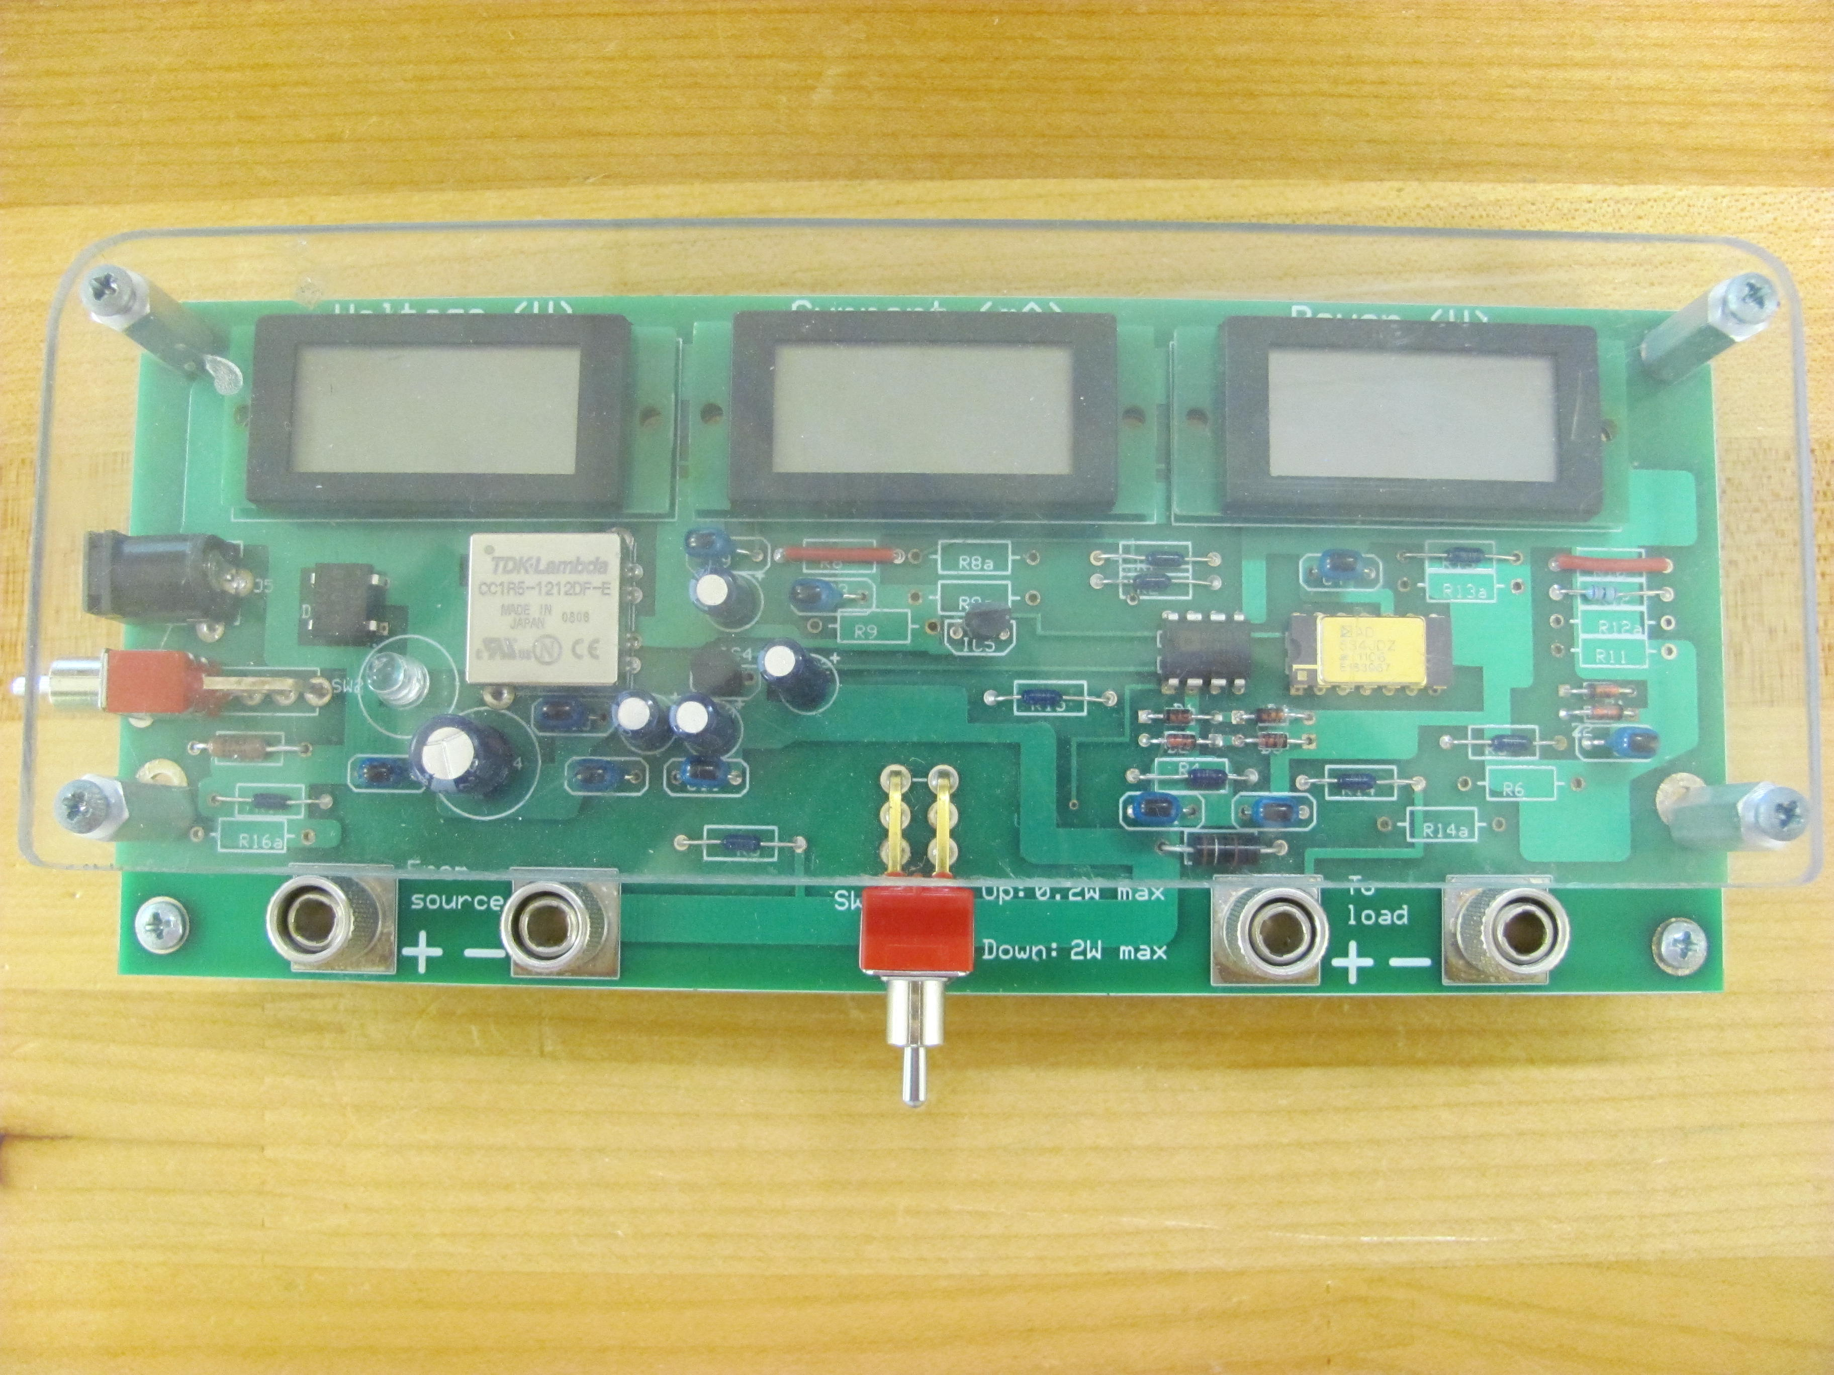
Figure A.2 The power meter measures voltage in volts, current in milliamps, and calculates the power in watts
As shown in Figure A.3, there are two pairs of wiring connections near the front edge of the Power Meter board.
- Connect one pair of the connections (on the left side) to the source of the energy.
- Connect the other pair to the circuit that uses energy (the load side).
The designation of ‘source’ and the ‘load’ is only for reference. The actual connections are not critical. If the power flow is from the left connections to the right connections, the display will show a positive power reading. If the power flow is in the other direction, it will show a negative number. In fact, in some applications, the power flow direction changes with time.

Figure A.3 Top view of the power meter. Note that you must connect a DC adapter at the left side to power the meter.

As shown in Figures A.2 and A.3, the first digital display on the left shows the voltage across the wires (the connections) and the center display shows the current through the wires (from the left connections to the right connections). The one on the far right shows the power in W. The switch (located between the connections) changes the metering range from 0.2 W maximum to 2 W maximum. When you flip the switch up or down you will notice that the decimal points moves on the power display.

The hardware for facilitating the wire connection is called a ‘binding post’ (see Figure A.4).

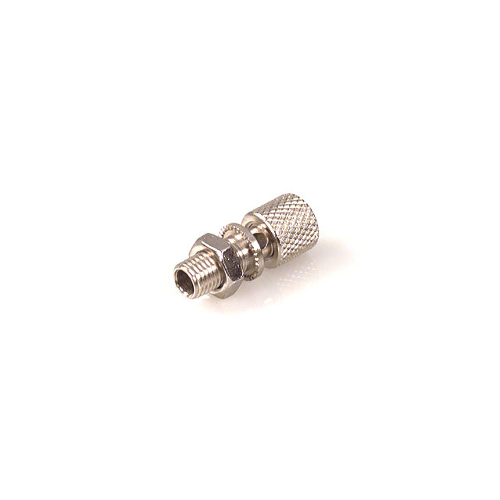
Hole

Figure A.4 Binding Post. A binding post has a hole through which you insert the wire you wish to connect and tighten the cylindrical knob to make good electrical contact.

To make a wire connection to the binding post, you first unscrew the top cylindrical knob to expose the hole on the post. You insert the wire through the hole (or you can loop the wire around the post). You then tighten the knob so that it presses down on the wire. Do not unscrew the knob so that it comes off the post and do not screw down too hard and cut off the wire.
Potentiometer
Figure A.5 shows a picture and the circuit symbol of a potentiometer (called a ‘POT’ for short). The one you use in class might look slightly different. The internal structure of a typical potentiometer (POT) closely resembles its circuit symbol. Inside a POT, there is a strip of conducting material (or, more precisely, a resistive material). For a rotary POT, the kind we have in the lab, this conducting strip is in a circular shape. Two ends of this conducting material are connected to two side terminals. The center terminal is connected to one end of a ‘wiper’. The other end of the wiper touches the conducting material. The position of the wiper tip can be adjusted by turning the shaft of the POT. As the wiper contact moves closer to one of the terminals (say, the left one), the resistance between this terminal and the center terminal (between the left terminal and the center wiper) becomes smaller. In fact, if you turn the shaft all the way clockwise to a stop, the resistance between these two terminals becomes zero.

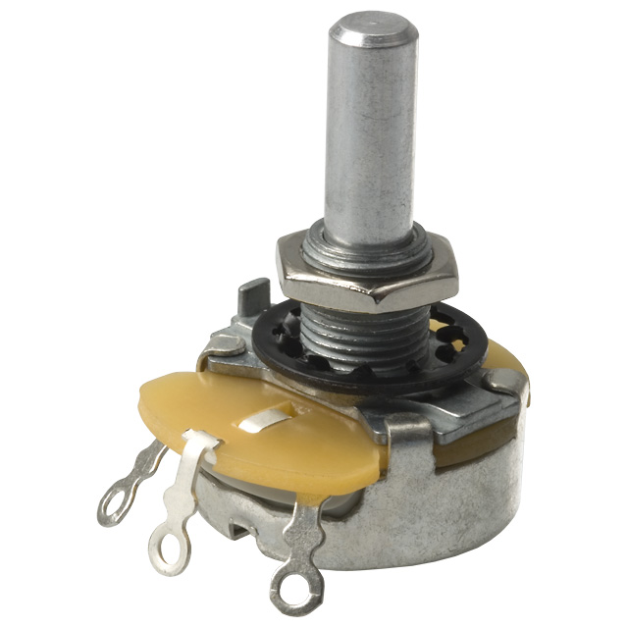
Figure A.5 Potentiometer. A potentiometer (POT) is a variable resistor. The resistance between the center wiper terminal and either of the end terminals depends on the rotation angle of the shaft.
A POT is rated by its end-to-end resistance and its power rating (the maximum power that it can dissipate without burning out). We have three types of POTs in the lab: 10Ω, 50Ω, and 250Ω. All three types are rated at 5W. Note that power rating of an electronic component is a rating of a how much power the device can safely dissipate. The component does not (and, in fact, will rarely) dissipate this amount of power in a normal operating condition. Since your solar system will not generate more than 5W of power, it is safe to use these POTs as the load (where all the energy generated will be dissipated).

