Digital Signal Input and Output
Learning Objectives:
After successfully completing this lab, students will be able to:
- Describe the digital input and output functions of the ATmega16 microcontroller
- Read logic level signals from an input port
- Set logic level signals on an output port
- Use ICs to perform chips to perform higher-level logic functions
- Create software functions to replace specialized ICs, and to consider software/hardware trade-offs
Components:
Qty. Item
1 Atmel ATmega16 microcontroller with STK500 and serial port cable.
1 SJSU-made dual, common anode (CA) 7-segment LED display board with integrated current-limiting resistors
1 SJSU-made dual 7447 BCD to 7-segment LED decoder board with STK500-compatible 2x5 header connector
1 SJSU-made 7-segment LED board to STK500-compatible 2x5 header converter board
Introduction:
In this lab you will explore a small portion of the input/output capabilities of the ATmega16 microcontroller. Microcontrollers are inherently digital devices, which means they operate with discrete values, usually the binary values 0 and 1 corresponding to the voltages 0V and 5V respectively. The discrete value of 0V is considered a “Low” or a logical 0 and that of 5V is considered a “High” or a logical 1. The ATmega16 microcontroller can service up to 32 digital digital inputs or outputs. A digital output means that a program running on the ATmega16 can change the pin voltage to be either at common potential (0V) or at 5 V by writing a 0 or 1 to that pin. A digital input means that the world outside the microcontroller can change the voltage on the pin to either 0V or 5V, and the microcontroller will associate the respective value as a 0 or 1.
7-segment LED display
You will use a dual (two-digit) 7-segment light-emitting diode (LED) display as a digital output device and push-button switches as digital input devices. A 7-segment LED is nothing more than 7 LED’s arranged in a pattern that can form a character when the appropriate segments are lit. These displays come in two basic types: common anode (CA) and common cathode (CC). CA types have all of the anodes of the 7 LED’s connected together, and each of the 7 cathodes independent. Power is applied to the common anode, and a segment will be lit when its cathode is grounded. Figure 1 below shows a schematic diagram of a CA 7-segment LED. The letters as shown denote the particular LED segment.
Because it is almost always necessary to use a current limiting resistor between the cathode and ground, resistors have been designed into the board that you will be using for this lab experiment.
Two of the physical pins on the display are tied together (made ‘common’). For the CA-type of display, the two pins connect to the common anode. For the CC-type of display, the two pins connect to the common cathode. The board that you will be using preserves the pinout of the display with respect to the downward-facing headers on the board. The only difference is that the board contains resistors connect to each LED segment, sparing you the tedium of wiring-in 16 current-limiting resistors (this wasn’t the case in past semesters’ labs).
Figure 1. 7-segment LED Display Types (Common Anode (CA) and Common Cathode (CC)). Power is applied to both common anode pins (pin 13 and pin 14). A segment is lit when its cathode is then grounded through a current limiting resistor. Pin positions are numbered from 1 to 18.
7447 BCD-to-7-segment (CA) display driver
The most common way 7-segment displays are implemented is with a BCD-to-7-segment decoder/driver chip (BCD stands for Binary Coded Decimal). This chip takes a 4-bit binary number (like 0101, which corresponds to decimal 5) as an input, and when connected to a 7-segment display, it causes the proper LED segments to turn on and display the corresponding decimal number. The chip used with CA displays is the 7447. For CC displays it is the 7448. Figure 2 shows the pinout diagram for the 7447 and describes its operation. (The actual lettering on the chip may include other letters and numbers like, SN74LS47). By convention, Pin 1 on any DIP (dual in-line package) IC is always the lower leftmost pin when the IC is oriented as shown with the U-shaped notch, or dot toward the left. Pin numbers increase going counter-clockwise back around to the reference notch. Some IC’s will only have the notch or dot; some may have both. What advantage(s) and disadvantage(s) are there with using a dedicated decoder chip like the 7447 with a 7-segment LED display?
b
c
d
e
g
a
f
7447
8
1
7
4
5
2
3
6
9
16
10
13
12
15
14
11
B
C
D
A
+5 V
LT
BI/RBO
RBI
Figure 2. 7447 BCD-to-7-segment decoder driver chip. This chip takes a 4-bit binary number applied to DCBA, where A is the least significant bit (LSB), and internally grounds the appropriate pin 9-15, so that when these pins are connected to a 7-segment LED display through current limiting resistor, the corresponding decimal number will appear on the display. The 7447 is used to drive common anode (CA) displays.

Rather than using individual 7447 chips and wiring them to the 7-segment displays, you will be using a board that provides an STK500-style 2x5 pin header connection to the 7447s' inputs, into which is inserted the 7-segment display board. As you will see in the schematic diagram below in Figure 4, the leftmost digit's 7447's (A,B,C,D) inputs are provided on bits 4-7 of the header, and the rightmost digit's 7447's (A,B,C,D) inputs are on bits 0-3, respectively.
Power (VTG) and ground (GND) for the board are both taken from bottom two pins on the STK500's 10-pin header for whatever PORTx jumper block is used. Power is used to power the ICs, to tie-up any input connections high, as well to power the LED display inserted into its headers.
Switch input
You will use two of eight switches mounted on the STK500 to provide digital inputs. A switch is either on or off, hence it makes for a very simple digital sensor. These switches are called “momentary, single-pole, single-throw, normally-open (SPST-NO) push-button switches. They are also sometimes referred to as ‘tact’ (tactile) switches. Two leads on the same side of the switch are tied together internally, as are the two leads on the opposite side (See Figure 3). Although there are logically only two electrical connections to the switch, having four leads provides better mechanical stability and support. When the button on the switch is pressed, an electrical connection is made between the two sides. The eight switches on the STK500 board edge are accessible through the 10-pin header labeled SWITCHES.
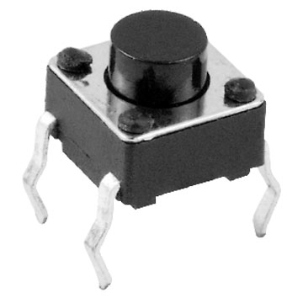
The switches and their associated header on the STK500 are implemented as shown in Figure 3.
Figure 3. Push-button ‘tact’ switch implementation on the STK500. Each of the eight switches is connected as shown. The electrical arrangement is such that the voltage on SWn will be at ground potential (and will read as ‘0’) if the button is being pressed, or the voltage will be at VTG (and will read as a ‘1’) if the button is not being pressed. The associated header is also shown. (Sources: tact switch picture from http://www.iphonexe.com/forums/images/Tact_Switch.jpg. Switch schematic from the STK500 User Guide, available at: www.atmel.com/atmel/acrobat/doc1925.pdf)
One side of each switch is connected to ground, while the other side is pulled up to 5V through a 10k resistor. The electrical arrangement is such that the voltage on SWn will be at ground potential (and will read as ‘0’) if the button is being pressed, or the voltage will be at VTG (and will read as a ‘1’) if the button is not being pressed. This configuration is called active-low, that is, when the switch is active (pressed), its digital output is low. This is in contrast to active-high, which is arguably the more intuitive way to think about it, but nevertheless not how these switches are wired on the STK500. Remember this fact about the switches on the STK500, as it will come up often in this and many later labs.
STK 500 Port Header Pins
As you know from the Intro to the ATmega16 lab, the STK500 has different port header pins, named PORTA, PORTD, PORTE, PORTB, and PORTC as shown in Figure 4. Note that because the ATmega16 has no PORTE, using the PORTE pins with an ATmega16 is futile.
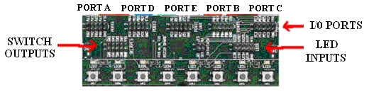
Figure 4. PORT, SWITCH, and LED headers on the STK500. Note, in order to use the switches and LEDs, a 10 pin ribbon cable needs to be connected between the headers and the I/O ports. Doing so will make a connection with the pins on the ATmega16. Note that the ATmega16 only has ports A-D. PORTE will not connect to anything when the ATmega16 is used.
Each header has 10 pins, one for power (VTG), one for ground (GND), and eight pins that correlate with each of the eight binary PORTA - PORTD bits labeled above. Under program control, we can force a pin to be either 0V or 5V, which are represented by the binary values of 0 and 1, respectively. The eight pins/bits are named '0' through '7'. Pin 0 represents the ones (2⁰) place, and Pin 7 the one-hundred-twenty-eights (2⁷) place. Datasheets generically refer to the pins (which are, in turn, connected to headers) as “PORTx:n” or “Pxn”. For example, if we wanted to specify Pin 3 on Port A we would refer to it as either “PORTA:3”, or “PA3”.
If you followed everything above, you should now have the ability to specify binary, hex and (only where it makes sense!) decimal numbers, as well as the names and locations of individual STK500 header pins connected to chip pins on an ATmega16.
Note: On the ME 106 website, under Lecture Notes, there is a program called ‘BlinkLED3.c’ and a program called ‘Simple-SW_LED3.c’ that you should review at this time. Understanding these programs will help you with this lab.
Interfacing to Port Pins
When writing programs, it is strongly recommended that you configure your ports and set their voltage levels before you get into the main part of your code. This is usually done in a separate initialization function, commonly called init(), as we do in this lab. There are generally four steps involved. The first is to set the pin’s direction, that is, specifying it as an input or an output using the corresponding bit in its DDRx (Data Direction Register) register. In the DDRx registers, 1 denotes output, and 0 denotes input. Second, if a pin is to be an output, in the init() function, set its initial voltage (either high (5V) or low (0 V)) depending on what makes sense for the initial state of the connected circuitry. Third, if a given pin is to be used as an input, enable its pull-up resistor, if necessary. Last, other configurations and initializations are performed, such as those for the ADC and UART.
For example, if you were using bits 7...4 as outputs (with initial values 1010, respectively), and bits 3...0 of PORTA as inputs (all with pull-ups enabled), and , your program would set DDRA=0xF0, and PORTA=0xAF in its init() function. Note also that “0xF0” may also be specified as “0b11110000”, and “0xAF” as “0b10101111” with pretty much equal clarity. You may also use bitwise arithmetic and “_BV(n)” terms to form these constant values if you choose to – for example, _BV(3) | _BV(2) | _BV(1) | _BV(0) rather than 0x0F.
Setting initial output pin voltage levels is especially important at power-up/reset so that they're in a known-safe state before either the hardware or software powers-up and starts running. For example, if one output pin was connected to a power interface driving the left arm of a laser-wielding robot, we might want to make sure that the pin voltage was set so that torching didn't begin until we determined that it was pointing in an appropriate direction. Less exciting perhaps, but arguably better.
Procedure:
In this lab we are going to build a numerical display circuit in which the on-board switches of the STK500 will provide inputs that influence the displayed value. Figure 4 shows a schematic for the circuit.
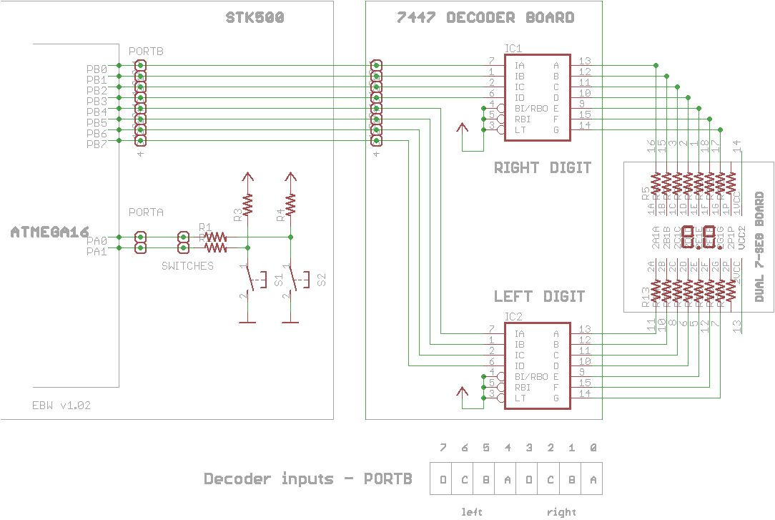
- Do not connect the STK500 to the display circuit just yet. This is to prevent running whatever random code was last programmed into the ATmega16 into the inputs of your display circuitry. You will be pre-programming your chip, and only then will you connect the two circuits together.
Figure 4. Switch-controlled display circuit. Two tact switches (SW1 and SW2) mounted on the STK500 provide digital inputs to the ATmega16, which in turn drives (by four digital outputs) a 7447 seven-segment decoder IC. Note the 10 kΩ resistors connected to the switches. These are called ‘pull up’ resistors, because they pull the voltage of pins PA0 and PA1 up to 5 volts when the switch is not pressed. They also limit the current to ground when the switches are pressed.
- Create a new project and enter, and run the mainDIO1.c code from the course website. Refer to, and perform, all of the AVR Studio configuration procedures you've learned in past labs. After you have downloaded your code to the chip, power off the STK500, and connect the 10-pin header on the decoder board (which connects to the two sets of ABCD inputs on the decoder chips) to PORTB on the STK500 with a 10-pin ribbon jumper as shown in Figure 5. Be careful of the orientation of the ends of the ribbon connector! See Figure 5 for the proper way to connect the 10-pin jumper. The header on the decoder board is laid out just like a PORTx header on the STK500.
Apply power to the STK500, and start the code running. What does the dual 7-segment display show? What would you expect the voltage at pins 9, 10, 11, 12, 13, 14 and 15 of the 7447 chip to be?
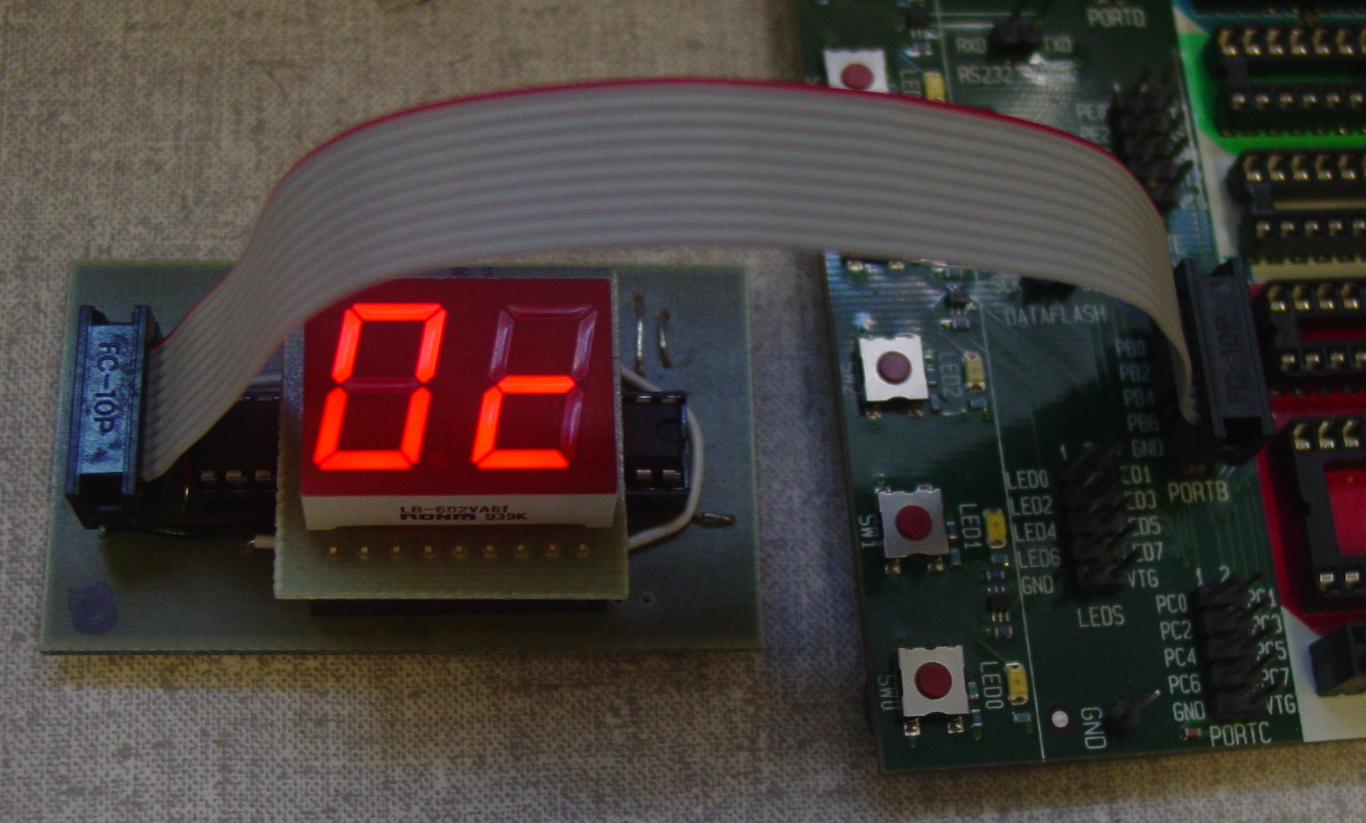 | 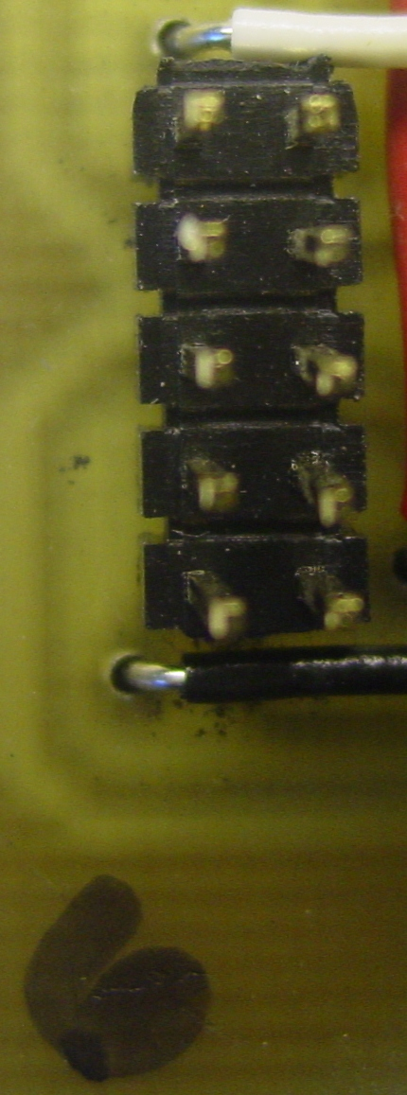
  RA | RB
  RC | RD
  LA | LB
  LC | LD
  Gnd | V_{TG}
Figure 5. 10-pin ribbon connection between PORTB on the STK500 to the 10-pin header on the display module. The 10 pins on the decoder board connect to the 7447 decoder inputs ABCD for the right (R) and left (L) display digits as shown in the table to the right. The jumper also connects V_{TG} and ground from the STK500 to power the module
- Modify the program to display ‘01’ on the display instead of ‘55’ (if '55' is not displayed, you have a problem which you need to fix before you continue). Which pins of the 7447 do you expect to be at 5V, and which are low when '01' is displayed? Experiment by displaying numbers between 0 and 9 on the different digits until you are satisfied with your understanding of what is happening with the ATmega16 pins, the decoder chip inputs/outputs and the LED board.
Before we continue-on with the lab procedures, a quick digression regarding how to compose the value of an output when it is composed of multiple, independent parts. The most common case of this (in this class) is constructing the contents of an eight-bit value of a PORTx or other control register, like that of the UART. In the simplest case, you might be trying to indicate eight independent conditions using eight LEDs, connected to one PORT (like when you connect one of the 10-pin jumpers to the LEDs on the STK500). The problem you are faced with is having pack together up to eight independent inputs (conditions) into a single eight-bit (byte) output value, ultimately written to PORTx.
The Decoder board you are using for the next few exercises packs together two four-bit values into one eight-bit value to be written into PORTB. The “trick” is getting all of the bits into the right places. You should already have a firm grasp of how to use the bitwise operators AND (&), OR (|), XOR(^) and NOT (~) in C to set, clear, and extract the relevant bits into or out of a larger storage unit (1, 2 or 4-byte value, typically). The other key piece of this is being able to use the bitwise shift operators << and >> for aligning the desired bit collections into or out of their destinations. For example, to set bit 4 in PORTB without otherwise changing its contents, you can write any of the following (remembering that PORTB |= x is the short form of PORTB = (PORTB | x):
PORTB |= _BV(4);
PORTB |= 0x10;
PORTB |= (1 << 4);
It should be noted that not all sub-values are single-bit values, some may be multiple bits wide. Let's say for instance that you had four two-bit outputs that shared one byte. Each of these four fields might occupy bits 76, 54, 32 and 01, perhaps each denoting one of the four compass points (representable in two bits – four possible values, right?) to point four independent Nerf cannons. If 00, 01, 10 and 11 denote N, S, E, W respectively, to point my four cannons North, North, East and South, one could write the following:
PORTB = (0b00 << 6) | (0b00 << 4) | (0b10 << 2) | (0b01 << 0);
Note that the converse is true. Say that I had a sensor that reported the directions of four of my known robot army adversaries, using the same encoding. I could extract this information similarly:
uint8_t myEnemiesDirs, army1, army2, army3, army4;
myEnemiesDirs = PORTB;
enemy1 = (myEnemiesDirs >> 6) & 0b11;
enemy2 = (myEnemiesDirs >> 4) & 0b11;
enemy3 = (myEnemiesDirs >> 2) & 0b11;
enemy4 = (myEnemiesDirs) & 0b11;
And while it's not nearly as common for us to perform the same operations on decimal numbers as computers do with binary numbers, there are cases (like today) where you might need to extract digits out of a decimal number. For example, how does one extract the three digits out of the number 357? If we had a decimal computer, it would be done the same way. We'd get the three by right-shifting 357 twice and masking out the low digit. Similarly to get the five, we'd right-shift once, and mask out the low digit, etc. The “problem” is that we the are no decimal-digit-masking and decimal-number-shifting operators. However, we do have the regular arithmetic operators, +, -, *, / and % that can be used to accomplish the same ends.
Hopefully these reminders, hints and tactics will help you accomplish what you need to with the two four-bit decoders on the Decoder board (and the direct-segment-access board) for the following exercises.
- Modify the program so that the display will count from 0 to 99 continually with a delay of 100 milliseconds second in between numbers. Include this code in your lab report. Hint: You are probably going to want to use a ‘for’ loop for this as demonstrated in the provided code template. By now you should know the syntax for a C-language 'for' loop, but if not, use the Internet to find either an example of one, or the syntax for it in a language reference. As an engineer, you will encounter many problems that will require you to investigate outside sources. You may also find significant hints by reading through the provided code.
- So far we’ve been dealing with the digital output capabilities of the ATmega16. Now let’s bring in the digital input capabilities. Let’s make the display circuit output “00” if neither button is pressed, “11” if SW0 is pressed, or “22” if SW1 is pressed. Complete the circuit in Figure 3 by wiring the two switches to the appropriate PORTA pins. Create a new project and enter and run the mainDIO2.c code from the course website. Explain how the switch statement is used to process the switch input state read through PORTA.
- To test your understanding of digital input and output, write a program that will cause the display to count up (continuously, with 0.5 second pauses between numbers) when SW0 is pressed and held down, and count down when SW1 is pressed and held. Also, ensure that the corner cases of rolling up through 99 and down through 0 are handled in a reasonable fashion (you can choose to stop at 0 and 99, or to roll over). Enter this code in your lab report for counting up with a 0.5 second pause between numbers. (Once more, significant hints on how to do this are available in the code, READ THROUGH IT!)
In the next part of the lab we are going to lose the BCD-to-7-segment decoder board and drive the segments of the LED display directly from the microcontroller. Once again, because the LED board contains current-limiting resistors between the inputs and each LED segment, you can drive them directly with 5V outputs from the PORTx pins. Because the display is common-anode, the LED segments are active-low – that is, setting a pin low turns the LED on. Be careful to insert the LED board into the adapter board so that the number of the board is in the lower-left corner as you are looking at it, and the decimal points of the display are also on the bottom side of the board.
You will be plugging the LED board into an adapter board that provides a STK500 2x5-pin header for each of the display's digits. The eight data pins on each header are connected to LED segments a through g on bits 0 through 6, respectively, with the decimal point for that digit on bit 7.
The sample/template code for this portion of the lab can be downloaded from the website, and is entitled direct7.c. Create and configure a new project incorporating this source and study its contents. It provides a template and some data (and does not compile as-is) to get you started with writing the programs in the following exercises.
7. Complete a program to count down continuously from 20 to 0 with one-second pauses in between.
8. Modify this program to count down continuously from 0x20 to 0x00 in hexadecimal. You will need to come up with acceptable representations of A through F for displaying on the LED display. Either upper or lower case styles are fine, or a mixture of the two, as long as they're mutually unique and intelligible.
9. Animate a single segment around the display on the right digit's display. The animation should cycle through lighting just segment a, then b, then c, d, e and f, returning to 'a' again, indefinitely. Pause for 0.1 sec between changes.
10. Modify the program in Part 7 to count-down from 20 to 10 (again, with one second pauses between them) and once 10 is reached, switch to displaying tenths of seconds during the sequence from 9.9 to 0.0. The entire countdown should be wall-clock accurate (tenth-second updates should be separated by 0.1 second pauses, rather than 1.0 second pauses). You must make use of the decimal point on the display.
11. Implement an up-counting stop-watch using a single button on the STK500 for start/stop/reset control.
Challenge (6pts Extra Credit!): How would you interface a dc motor and switch to the ATmega16, so that you could turn the motor on when the switch is pressed? Draw a schematic for your interface and write a short program C to implement your idea.
Note: The ATmega16 can only output 5V and 40 mA to a pin, which is likely not enough to power a motor or solenoid. You will most often need a power interface using a transistor (bipolar or MOSFET, as shown in the next experiment) to power a motor or solenoid. Also note that 40mA is an absolute maximum which you should strive to be well below, like by a factor of 2, to avoid damaging the chip.
Appendix A
DM7446A, DM7447A
BCD to 7-Segment Decoders/Drivers
Fairchild Semiconductor, 2001
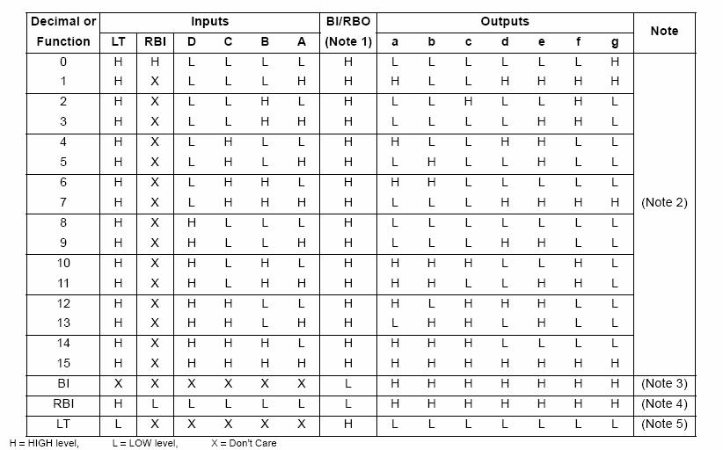
Appendix B - Hexadecimal Number Representation
Hexadecimal (also called “base-16”) is a numbering system in which there are 16 distinct symbols, 0-9 and A-F. While the digits 0-9 in a hex number represent the same decimal numerical values you are familiar with, the digit A in hex represents 10, B 11, C 12, D, 13, E 14 and F 15. Hexadecimal is often used in programming because a two-digit hex number can be used as shorthand to represent 8 binary values: the leftmost hex digit covers the leftmost four binary places and the rightmost hex digit covers the remaining 4 binary places. Just like the decimal number system you are familiar with, binary and hexadecimal numbers have place values. In a decimal number the rightmost place is the ones place (10⁰), the next place to the left is the tens place (10¹), the next is the hundreds place (10²), and so on. In a binary number the place values are (also from right to left): ones (2⁰), twos (2¹), fours (2²), eights (2³), and so on. Similarly, hexadecimal places are ones (16⁰), sixteens (16¹), two-fiftysixes (16²), etc. Places increase as powers of 16 in similar fashion to the powers of 10 in decimal numbers that you are familiar with.
To convert four binary digits into a hexadecimal digit, just add up each binary digit multiplied by its place value. Thus, for the binary number, 1010, 1(8)+0(4)+1(2)+0(1) = 10, which in hex is 'A'.
The same logic applies converting from hexadecimal values to binary. Choose the binary digits (0 or 1), so that when each is multiplied by its place value, it gives the hex value you are looking for. For example, hex E represents decimal 14, and 1(8)+1(4)+1(2)+0(1) = 14, so the corresponding binary number is 1110.
For the purposes of our class we will generally only be using pairs of hexadecimal digits, because ports and registers are grouped as eight pins (bits), and hexadecimal representation is more concise (and generally more convenient once you get it) than binary. Table 1 lists binary, hex, and decimal numbers from 0 through 15.
It is especially common to use hex digits to specify constants in C-language programs because they are a natural way to specify relatively long sequences of binary digits (bits) concisely. C makes this easy by using a prefix of “0x” on a constant to signify that the value is in hexadecimal. Consequently, one “always” specifies all-eight-bits-high in a register as 0xFF, rather than as 255. As it turns out, the compiler that we are using additionally implements a (non-standard) prefix of “0b” for specifying binary constants, so for example, “0b11111111” may also be used. However, once you get used to using hex values, you will likely prefer “0xFF” to “0b11111111” because the former is considerably easier to say, hear, read and type.
Table 1. Binary, Hexadecimal, and Decimal Values. HEX is a shorthand way to represent 4 binary digits.
Binary |  |  |  |  | HEX | Decimal
0 | 0 | 0 | 0 |  | 0 | 0
0 | 0 | 0 | 1 |  | 1 | 1
0 | 0 | 1 | 0 |  | 2 | 2
0 | 0 | 1 | 1 |  | 3 | 3
0 | 1 | 0 | 0 |  | 4 | 4
0 | 1 | 0 | 1 |  | 5 | 5
0 | 1 | 1 | 0 |  | 6 | 6
0 | 1 | 1 | 1 |  | 7 | 7
1 | 0 | 0 | 0 |  | 8 | 8
1 | 0 | 0 | 1 |  | 9 | 9
1 | 0 | 1 | 0 |  | A | 10
1 | 0 | 1 | 1 |  | B | 11
1 | 1 | 0 | 0 |  | C | 12
1 | 1 | 0 | 1 |  | D | 13
1 | 1 | 1 | 0 |  | E | 14
1 | 1 | 1 | 1 |  | F | 15

