Exercise 5 - Using Waveform Graphs

Front Panel
1. Open a new VI and build the following front panel using the following tips.

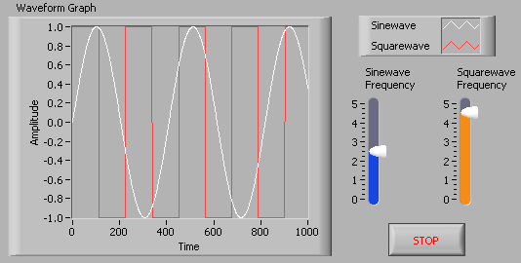

- Create a waveform graph indicator from the Controls»Graph Indicators palette. Use the position/size/select tool to move the plot legend to the side, and expand it to display two plots. Use the labeling tool to change the plot names and the properties page to choose different colors for your plots.
- Place a Stop button on the front panel.
- Place two vertical pointer slides from the Controls»Numeric Controls palette. Use the properties page again to change the slide fill color.

Block Diagram

2. Build the following block diagram.
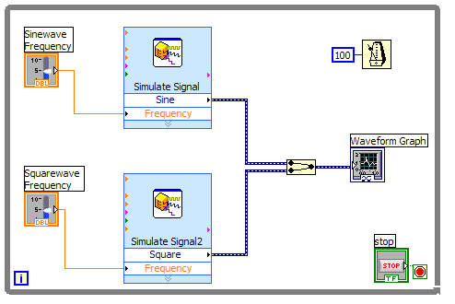

- Place a While Loop from Functions»Execution Control palette.
- Place a Wait Until Next ms Multiple from Functions»All Functions »Time & Dialog and create a constant with a value of 100.
- Place two Simulate Signal Express VIs from the Functions»Input and leave the Signal type as Sine for the first Simulate Signal VI and change the Signal Type to Square for the second VI. Wire both of the outputs into the waveform graph. A Merge Signals function will automatically be inserted.
- Expand the Simulate Signal Express VIs to show another Input/Output. By default, error out should appear. Change this to Frequency by clicking on error out and choosing Frequency.

3. Save the VI as Multiplot Graph.vi.

4. Display the front panel and run the VI.

5. Save and close the VI.

End of Exercise

