Contents page

SmartMotor SMI Software 5

Opening Screen 5

Serial Communications Set-up 6

Addressing SmartMotors 7

Serial Communications Troubleshooting 8

Monitor Status Window (Polling Motor) 9

Editing Programs and Downloading them to the SmartMotors 10

Advanced Monitoring 11

Advanced String set-up 12

Advanced Status Example 13

Defining Macros for the Terminal Screen 14

SmartMotors Hardware and Control at a Glance 15

Supplying Power to SmartMotors 15

NEMA 17, 23, and 34 frame sizes

NEMA 42 and 56 frame sizes

CPU, I/O, and Communications Power restrictions

CPU Power

I/O Restrictions and limitations

Communications

Programs, Variables and Modes of operation 16

Programs

Variables

Modes of Operation

Motor response to Loss of power and Faults

Loss of Power

Hardware Protection Faults 17

SmartMotors Hardware and Control at a Glance (Continued)

Software protection faults 17

Motor Response with respect to Motor Tuning

Motor Torque Limits

Error Handling and Motor Status Bits and Internal conditions 17

SmartMotor Communications at a Glance 18

Notes on Boot-Up sequence of SmartMotors 18

Multiple motors on a communications line

RS-232

RS-485

Pre-Addressed Motors on Boot-Up 19

Global addressing:

Addressed or De-Addressed state: 20

Addressing SmartMotors from a Host PC or other Serial Device 21

SmartMotor Program Flow at a Glance 22

Introduction of the SmartMotor Language 22

General Expressions 23

Assigning values
Math operators
Comparison Operators

Flow Control Commands 24

IF, ENDIF

ELSE, ELSEIF
SWITCH, CASE, DEFAULT, BREAK, ENDS 25
WHILE, LOOP 26

Subroutines, Flow routing, and Timing 27
GOTO#
GOSUB#
STACK 28

WAIT, CLK 29

TWAIT 29

SmartMotor Modes of Operation at a Glance 30

MP Mode Position (Position Mode) 30

MV Mode Velocity (Velocity Position Mode) 32

MT Mode Torque (Torque Mode) 33

Mode Follow (Electronic Gearing) 34

MF1, MF2, MF4, MF0, RCTR

MFR, MFMUL, MFDIV (Mode Follow with Ratio) 35

Phase Offset Adjust in Mode Follow 36

Mode Step (Receive Pulse and Direction Inputs) 37

MS, MS0, RCTR Standard Mode Step
MSR, MFMUL, MFDIV Step Mode with Ratio

Mode CAM (Electronic Camming) 38

Motion Commands summary 40

A Acceleration
D Position (Relative commanded)
E Position Error
G Go
I Index Position
O Origin
OFF Disables Drive Amp
P Position (absolute commanded) 41
S Fast Stop
T Sets commanded torque for Torque Mode
V Velocity
X Decelerate to a stop
@P Real-time motor position
@V Current Commanded Velocity

SmartMotor I/O Control at a Glance

I/O Port Hardware 42

Software Control of I/O Ports

Reading a Port as an Input

Assigning Port status to a variable 43

Reading a Port as an Analog value

Assigning a Port as an Output

Default States and special uses of I/O ports 44

Ports A and B Defaults and Specifics

Ports A and B as quadrature encoder inputs

Ports A and B as Step and Direction inputs

Ports C and D Defaults and Specifics 45

Ports E and F Defaults and Specifics

Ports G Defaults and Specifics

I/O Programming examples 46

Level Triggered Subroutine call

Positive-Edge-Triggered Subroutine Call

Negative-Edge Triggered Subroutine Call

Level and State Change Print-Out example

SmartMotor SMI Software

1.Opening Screen

After installing Software, you should have an Animatics heading in your Programs menu with the SmartMotor Interface Icon available.
Start it up and you should see this screen:

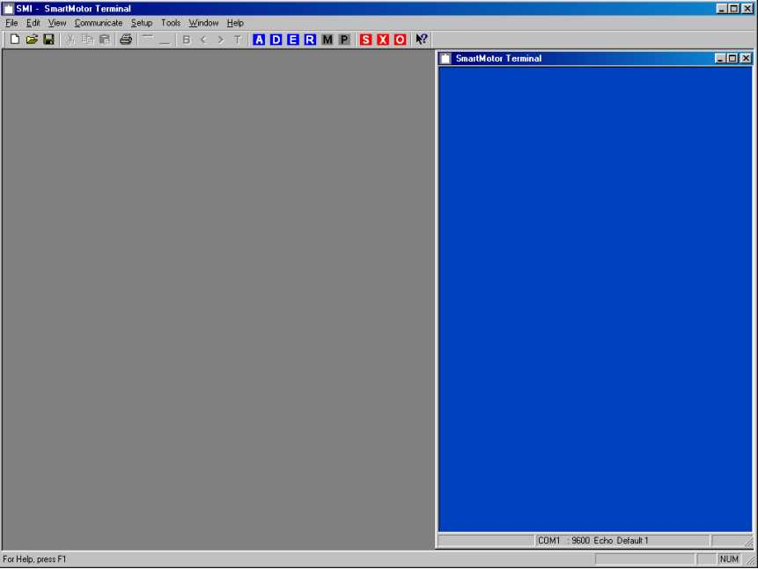

You will notice various Icons across the top and a blue terminal screen to the right side.
All of the Icons are “Smart” Icons. Holding the mouse pointer over them will give you instant on-screen help.
The drop-down menus operate just like any standard Windows based software.

The first thing you will need to do is set up your Serial port to be able to communicate with your SmartMotor.

2. Serial Communications Set-up

Click on the Setup Drop-down menu and select Configure Host Port.
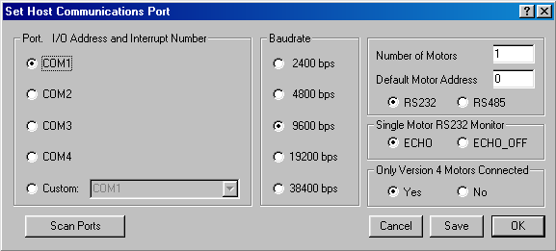You should see this screen:

You need to choose which serial port you will be using with your SmartMotor.
If you are using a Laptop, make sure there are no conflicts with your serial port. Some Modem Cards tend to lock onto Com1 or 2 and as a result it may be necessary to reboot with it removed.

As you can see, The software gives options to talk to more than 1 motor at the same time as well as the ability to use an RS-485 port is you have on installed. The Software uses Windows system drivers and will scan for them if needed. The option buttons for motor version allow backward compatibility to earlier version motors. All motors from early 99 on are version 4.0 or higher.

Note: All SmartMotors (assuming no program has been downloaded) power up in the “Echo_Off” state with a default address of zero and a baud rate of 9600.
Any selections made in this window will be sent to the SmartMotor upon addressing them and only remain active for the current serial communications session unless a program is downloaded that contains these parameters. The Save button will save these parameters in the SMI Software only.

Once you have set up your software, either click Save to keep these setting for the next time or OK to use them just for this session.
At this point, you should have a SmartMotor powered up and it’s serial port connected to your computer.

3. Addressing SmartMotors:

You can “Address” the SmartMotor in one of 2 ways: Select Communicate drop down window and
Addess Motor Chain menu item or click on the blue “ A” Icon.
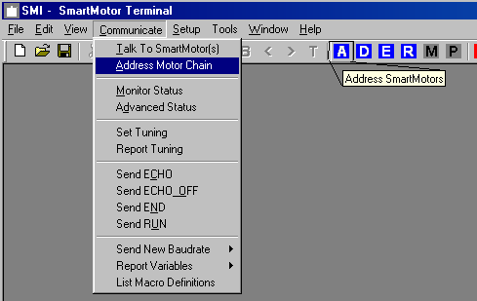
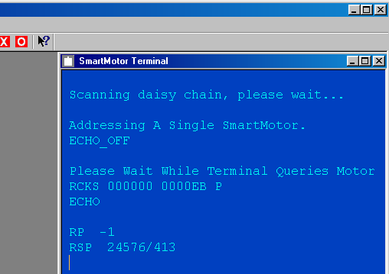Once you click on one of these you will notice the Terminal window displaying a series of information.

This is the result you should get if your motor is “out there” and working properly.
“Scanning daisy chain,….” Means it is sending messages out to the SmartMotor/s and looking for a return message. Then upon doing so, it uses your serial port settings to set up motor addresses and set the proper echo status for each motor you have connected. If you only have one connected, it will leave the Echo State in “Echo_Off”. If you have more than one motor connected and are using RS-232, it will need to be in “Echo” so as to get messages through the first motors into the trailing motors and them back to the host.
RP is the command to report position. RSP reports serial number and firmware version.
RCKS is a checksum report to insure there are no serial communications problems.

4. Serial Communications Troubleshooting:

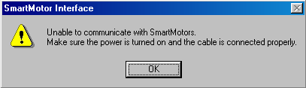If you get this message when addressing SmartMotors, this usually means you are not plugged into the right port or the motor may not be powered up.

Other thing to check would be baud rate. IF the motor has an existing program in it and was set up with a different baud rate, the SMI software will not be able to talk to it.
If the SmartMotor has a program running and is continuously sending out messages on the serial line, this will sometimes cause a conflict. All SmartMotors have a ½ second delay between Power-Up and running a program. This ½ second is to allow the motor to check for any incoming characters on the serial port. If a motor gets anything on the port within this ½ second, it will not start its downloaded program.
To see if this is the problem, power down the SmartMotor, place the mouse pointer over the “E” icon and
Right after powering up the motor, click on the “E”. This sends the END command to the SmartMotor and prevents it from running it’s program on power up.
You can also type END at the terminal screen and Press the enter key right after power-up.
The basic idea is to send anything down to the motor within that ½ second boot-up time.

If you get this message:


Then you have something else already using the selected serial port. You will need to resolve the conflict.
This is usually due to Fax/Modem hardware or software conflicts.
If you are using software that automatically checks for incoming faxes or that uses a dial-up modem card, you may need to choose another serial port or disable the conflicting software during use of the SMI software. You may also want to check IRQ conflicts if it is at the hardware level.

One other rare problem brings up this window upon software install.
If your computer does not have Com1 or Com2 you will get this message on start-up.
In this case, go to the Animatics/SMI directory and delete “commport.cfg”.
This file defaults to ports 1 and 2. Once you delete it, you can start up the SMI software, (you will still get the message), but now you can go into the set-up and change to an existing COM port.

5. Monitor Status Window (Polling Motor)

Under the Communicate menu, you will see Monitor Status. This is a window that the SMI software uses to display various motor parameters and conditions while you have a motor addressed and on line.
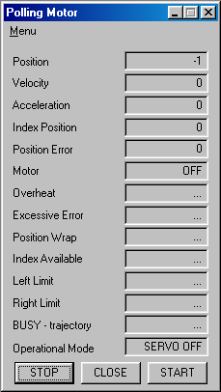
This window is very much like a small terminal window. It is actually sending down commands in the background and displaying the motor responses in the associated windows as shown.
For Instance, It sends out RP (report position) and gets back a “-1” in this case for position. Once it gets this back, it sends out RV (report velocity) and gets back a “0” and then continues on with the rest of the commands.
You should remember this too. If you write a program that sends out data on the serial port, it may conflict with the monitor status window and cause bad data to show up. If this is the case and you want to get responses back from the motor, you can press STOP on the Polling Motor window.

To give you and idea of the actual information in this window, This is what you are getting:
The values for Accel and Velocity are PID buffered values.
“Motor” is telling you if the motor is on or off. When on, this just means the Drive Amp is providing current to the motor windings. When off, the motor will free spin and the Drive Amp is off.
OverHeat: High Temp status Bit.
Excessive Error: Position Error Status Bit
Position Wrap: Motor has gone past 2^31 encoder counts in positive or negative direction.
Index Available: Real time look into index tic mark.
Left and Right limits are also real-time indicators.
Busy-trajectory shows if the motor is actually trying to move to some point or not as being commanded by the PID filter.
Operational mode will display what mode the motor has been set to, i.e.: Velocity Mode, Position Mode, Mode Follow, Mode Step etc…...

6. Editing Programs and Downloading them to the SmartMotors.

Under the File drop-down menu, select New and the blue text editor screen will appear:
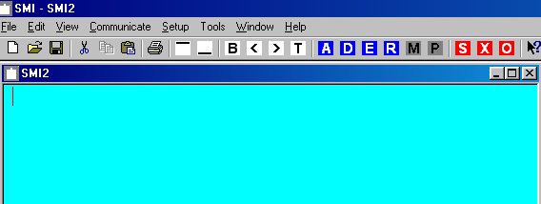
This is a simple text editor for editing or creating programs. It works like any Windows based text editors with all of the same cut/copy/ and paste capabilities as well.
It will show a default name (SMI2 shown here).
The software will prompt you to save it under some specific name before you can “build” it or download it.
There are many examples in the SMI help file, which can be copied and pasted into the text editor.
Once done, you can save the changes and build and download your program to the SmartMotor.
Here is an example of building and downloading a program:
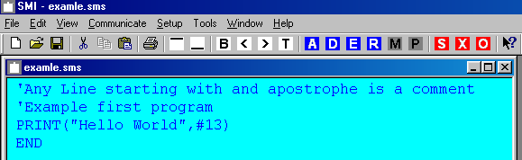
To build a program is similar to compiling programs in other software. The “B” icon builds it. The “T” Icon both builds and transmits it to the motor.
In both cases the software checks for errors. Clicking on the “B” will cause the SMI software to scan for errors and if any, it will display an “ERRORS FOUND” window. Otherwise, it leaves you back in the edit screen.
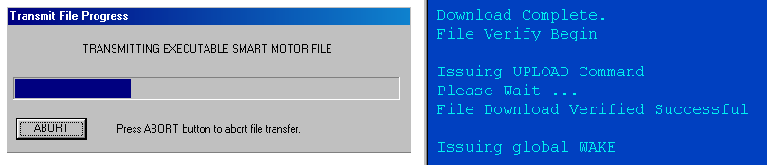Clicking on the “T” icon will build and then transmit the program to the SmartMotor.
You will see this while downloading, And This when complete.
It always downloads to the default motor as is set up in the serial port set-up window.

7. Advanced Monitoring

Occasionally you may want to monitor a given variable or a condition of a port.
Under the Communicate menu, you will see Advanced Status. This is a window that the SMI software uses to display custom set-up motor parameters and conditions while you have a motor addressed and on line.
Like the standard Monitor status window, it sends out report commands to the motor in the background. Additionally, however, you can send stings of commands to tailor your reports to specific needs.

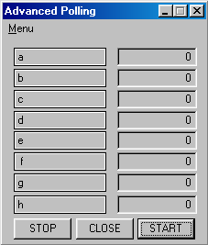This is what the screen looks like by default:

If you click on any of the blocks down the left side (i.e. a-h), this window will appear:
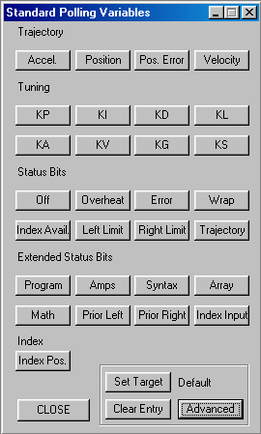

This is where you can customize your monitor status. If you clicked on the block with the a in it, by clicking on any of the option blocks above, the a will be changed to that option, i.e. clicking on Pos. Error
Will cause the block to now display motor position error. You can pick and choose any of them for each of the blocks a-h that you wish.

8. Advanced String set-up

There may be a case where you want to monitor a specific hardware port status.
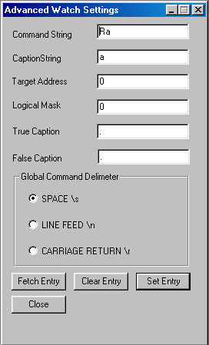If you click on the lower right hand block called “Advanced” in the Standard Polling variables window, this will show up:

This window allows you to put in custom strings.
The Command String box is the actual ASCII string sent to the SmartMotor.

Command String Enter string to transmit to SmartMotor

Caption String Enter string to display in Advanced Polling dialog

Target Address Enter, in decimal, command target SmartMotor address

Logical Mask Enter, in decimal, logical AND mask to apply to SmartMotor response value. If this value is ZERO no mask is applied.

True Caption Response string to display if SmartMotor response value ANDed with the Logical Mask is a non zero value

False Caption Response string to display if SmartMotor response value ANDed with the Logical Mask is zero

Global Command Delimiter The character appended to the end of the Command Strings

Fetch Entry Button Fetch the present user defined configuration entry

Clear Entry Button Resets the present user entry to null settings

Set Entry Button Place user settings in present watch configuration

Close Close the dialog

9. Advanced Status Example

Here is an example of monitoring port C as an analog value.

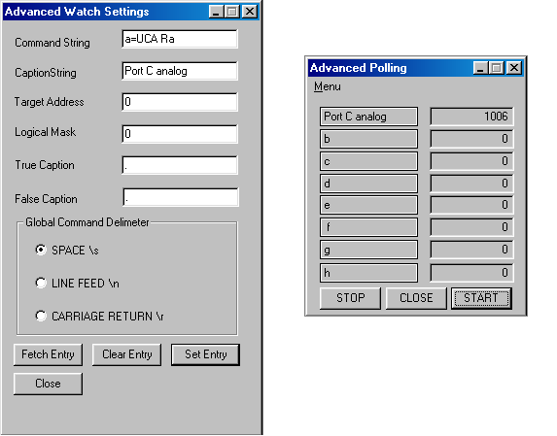
Notice how the command string was typed in. : a=UCA Ra

There is a space between UCA and Ra. This is required because this would be the same as writing code for the motor. The caption string is what shows up in the block as seen on the right. The target address refers to which motor you want to monitor. If you have more than one motor connected, you would put the address of the motor you wish to monitor into that block. Logical masks are a means to compare a value with the motor’s value. If you were to type in 1006 in this case and types yes for true caption and no for false caption, every time the port value came back as 1006, the status would be “yes”, otherwise it would be “no”.
Basically, the logical mask number is “Anded” into the value received from the motor. The captions are then displayed according to the result.
If you put too much into the command string, it may cause an error in communications. Remember that the string is sent in the background, so if your motor program is using the serial ort, there may be some problems.
It is recommended not to have any other serial port control going on while using the monitor status controls.

10. Defining Macros for the Terminal Screen

One other useful aid in troubleshooting or development of SmartMotor programs is by making use of Terminal Macros.
Macros are predefined routines that can be called up at any time to execute multiple keystrokes for you.
This prevents you from having to type in the same sequence of keystrokes over and over again.
Under the Help menu you will see “Terminal Macros.”
Clicking on it will bring up this window:
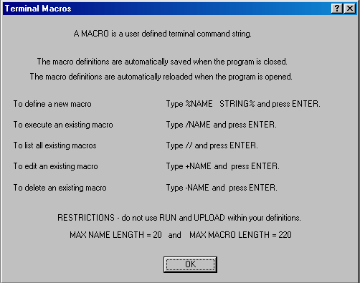
This is an overview of how to define and call up macros.
For instance, if you wanted to make the motor go into electronic gearing at a 10:1 ratio while tied to another SmartMotor, it would require a bit of typing. If you wanted to just cal up a macro to do this for you, this is what you would do:

Type in at the terminal screen the following:

%Gear10 MF4 MFMUL=1 MFDIV=10 MFR G % (then press enter)

You have just defined a macro called “Gear10”
To execute it, type /Gear10 at the terminal screen prompt.
The macro will send down the string as you typed it in the macro :

MF4 MFMUL=1 MFDIV=10 MFR G
Notice that I left a space after the G. The SmartMotors respond to a space and carriage return the same.
At any time you can use this macro. The Macros are saved in the SMI software and in no way are they tied to a SmartMotor program itself.

SmartMotors Hardware and Control at a Glance

All Items here are important points of reference:
(please see appropriate sections in the manual or help files for more detail)

Each SmartMotor is an Integrated Motion controller, Drive Amp and Motor.
As a result, care should be taken with regards to hook-up, communications, and control.

Supplying Power to SmartMotors:

NEMA 17, 23, and 34 frame sizes:
All SmartMotors in frame sizes from NEMA 17 to NEMA 34 run off of 24-48VDC. Under no circumstances should they be allowed to run off of any higher voltages. Lower voltages could cause a brownout shutdown of the CPU or what would appear as a down power reset under sudden load changes. If power is reversed on any NEMA 17-34 frame size SmartMotors, immediate damage will occur and the SmartMotor will no longer operate.
Note: During hard fast decelerations, a SmartMotor can pull up supply voltages to the point of damage if a shunt resistor pack is not used.

NEMA 42 and 56 frame sizes:
All SmartMotors in the NEMA 42 and 56 frame sizes can run off of 100 to 240VAC single or 3 phase. Damage will occur if they are connected to a 480VAC bus. The 42 and 56 frame motors can be run off of 80-300VDC busses as well. Since they have full wave 3 phase bridge rectifiers on the input, DC power con be applied to any 2 of the 3 AC input pins at any polarity.

CPU, I/O, and Communications Power restrictions:

CPU Power:
All SmartMotors have an internal 5VDC Power supply to run the internal CPU. This supply can be easily damaged if an external voltage source of a higher potential is applied. Do not exceed 5VDC on and I/O pin or 5VDC pin on any SmartMotor.

I/O Restrictions and limitations:
Each on-board I/O pin has a minimum amount of protection consisting of a 100-Ohm Current limit resistor and a 5.6VDC Zener diode. Each I/O pin also has a 5Kohm pull-up resistor.
When assigned as outputs, they act as a push-pull amplifier that drives hard to either the positive or negative 5VDC rail. This means they are not open collector I/O pins. Each I/O Pin can sink up to 15mA and source up to 4mA. Exceeding this could result in damage to the I/O port.

Communications:
Each Motor has a 2 wire RS-232 port. This port meets IEEE standards with full +/- 12VDC potential on the transmit line. Proper serial ground signal referencing and shielding techniques should be used.
Under no circumstances should the shield of a cable be used for the RS-232 ground reference. This could result in noise or corrupt data as well as ground loops that could damage the serial port chip set.
Each SmartMotor boots up default to the ECHO_OFF state. This means that nothing received is transmitted or echoed back out. This is important to remember in serial “daisy-chain” set-ups. They also boot-up defaulted to base address zero meaning they will listen and respond to any incoming valid SmartMotor commands.

Programs, Variables and Modes of operation:

Programs:
All SmartMotors will run any valid program stored in memory upon boot-up by default. The only way to prevent this is to add the RUN? command at the top of the program or send any communications to the SmartMotor within the first 500msec.
Any PRINT statement containing long text strings should be reviewed carefully. Any text strings that appear as valid commands could cause other motors in the “Addressed” state to respond. using GOTO and multiple GOSUB or GOTO calls from multiple sources could cause unexpected results. This can cause the program stack pointer to become corrupt. At that point the CPU will not know where to go in the program. (Multiple sources means from the RS-232 port, RS-485 port and/or Program.)

System and User Variables:
Each SmartMotor runs and operates from volatile RAM. This means that upon loss of power, all variables lose their present value and will be zero at the next power-up. All tuning parameters will return to factory defaults. Motor addressing will re-set to zero. Clock, Counter and Position registers also reset to zero.
The only way to insure desired values upon power-up is to store them in hard code in a downloaded program.
All SmartMotor variables are pre-defined as shown in the manual and help files. No user defined variables are available. All variables are global within a single SmartMotor. This means that any update or change to a variable will be seen in any subsequently called subroutines. If it is desired to have local variables to a given subroutine, they should be assigned the needed value within that subroutine as needed.

Modes of Operation:
Mode Set (MS), Mode Follow (MF1, MF2, MF4), and Torque Mode (MT) are the only modes that do not require a “G” command to initiate. This means the mode will be immediately initiated upon receiving the associated Mode commands. This could result in immediate shaft movement. Be careful when initiating these Modes of operation.
Mode Follow Ratio (MFR) and CAM Mode (MC, MC2, MC4, MC8) both require a “G” to become fully effective, however, they also require Mode Follow commands in their set-up. This means that during the set-up process, motor shaft movement could result.
All other modes require a “G” to initiate or to change velocities and/or accelerations.
Port G on all motors defaults to “G –sync” which means if it is grounded, it will be no different that having received a “G” command. If Port G is grounded prior to power-up, the processor will see this as a valid “G” command upon boot-up. Depending on code, this could cause unexpected motor shaft movement.
The “D” register is the relative commanded move register. Any non-zero values of D could result in unexpected moves upon any valid “G” command be it from the “G” command or the grounding of port G.
SmartMotors default to position mode on boot-up. They only require a non-zero velocity and accel a long with a non-zero D value or P value other than present position to initiate a move.

Motor response to Loss of power and Faults:

Loss of Power:
All SmartMotors will coast or “free-wheel” on loss of power. This is because there is no control power to prevent it from occurring. You may notice what appears as a dynamic braking characteristic upon loss of power. This occurs to some extent due to internal capacitance in the drive amp circuit or external power supply circuit resistance or capacitance. To insure fast fail-safe stopping for safety reasons, some mechanical brake type of mechanisms should be used.

Hardware Protection Faults:
In all firmware revisions prior to V4.76, Motor hardware protection faults (Over Current and over Temp) result in “free-wheel” of motor shaft. This is to prevent further damage to the motor or drive amp. Versions 4.76 and later implement dynamic braking on error.
(back to top)

Software protection faults:
Limit switch inputs and Position error limits are both “software” protection faults.
This means they are not firmware unchangeable. The effects of Limit switches and Position error can be changed via valid software commands or set-up parameters.
Position error is predicated by a value set by the user and can drastically effect motor response under varying load conditions and tuning. Limit switches can be set up to cause the motor to servo in place instead of free wheel. Refer to specific firmware addendums for various limit switch options and capabilities.
(back to top)

Motor Response with respect to Motor Tuning:
Care should be taken with any closed loop servo with regards to motor tuning. Improper tuning may cause undesired effects ranging from excessive noise and vibration to mechanical damage to a machine or overheating of the motor or drive amp.
Improper tuning can also lead to repeated or undesired amounts of over current or position errors. Proper tuning can make or break a successful application

(back to top)

Motor Torque Limits: {AMPS command and T (Torque) command}:
Motor T (torque) command is only for use in Mode Torque (MT). It has no effect on motor operation outside of Mode Torque.
The AMPS command has effect over all other modes of operation. It limits absolute maximum power available from the drive amp to the motor windings as a function of percent duty cycle of PWM (Pulse Width Modulation). The AMPS command should be used when it is desired to limit motor torque to a sensitive or torque input limited load. IT may also be used to reduce the chance of reaching peak over current errors on high acceleration applications.

(back to top)

Error Handling, Motor Status Bits and Internal conditions:
SmartMotors have a 16 Bit status word that contain interrupt registers triggered by selected events. These events include Position Errors reached, Over Current reached, Limit switch conditions, Syntax errors and so on. In addition, in the newer motors, Bus Voltage, Drive Current, and Motor Temperature are also available. By proper use of these status bits very simple and very flexible error handling can be achieved. Motors can be made to respond under varying load conditions in different ways and recover from any given software or hardware fault in a controlled manner.
Please review this in detail in the manual and help files.

(back to top)

SmartMotor Communications at a glance

Notes on Boot-Up sequence of SmartMotors with regards to communications:

SmartMotors default to 9600 Baud, no parity 8 data bits and 1 stop bit. (9600,N,8,1).
All SmartMotors boot up in ECHO_OFF mode with global address zero.
This means they will respond to globally addressed commands, i.e. commands proceeded by dec128 or hex80.

With in the first 500msec’s or so of power up, if they have not received any serial communications, they will begin executing code previously downloaded to them from the top down.

If the Code begins with RUN? , execution will stop at that line until a “RUN” is received via RS-232 serial port.

Multiple motors on a communications line
If more than one motor is to be placed on a communications line, they must be set up properly to avoid communications errors.

RS-232
If RS-232 is used from a host PC or other RS-232 compatible device, all motors must be in ECHO mode.
While in ECHO mode, all data reaching a motor’s received pin will be “echoed” back out it’s transmit port.
Since RS-232 serial lines must be daisy-chained together, the motors must be in ECHO mode to work properly.

RS-485
If RS-485 is used, all motors must be in ECHO-OFF mode. RS-485 is a parallel communications network. If any motor was to echo out commands received, it would cause all motors or any other devices on the network to get hit with the same data.

Note: SmartMotors use 2 wire RS-485 standards. This means line biasing determines whether or not the motor is in transmit mode or receive mode at the hardware level. To insure motors do not hang up in the transmit mode, there must be a minimum of a 200mVolt differential between RS-485 A and B channels.

This is easily achieved by placing a pull down resistor of approximately 500 Ohms from the B channel to ground somewhere on the RS-485 network.. All SmartMotors have a 5Kohm pull-up resistor on both A and B channels already. The 500 Ohm resistor will provide the enough biasing needed to make the hardware default to the receive state. If there are long distances between motors, it may be necessary to provide a resistance across channels A and B. A 200 Ohm resistor wired from A to B at the remote end of the RS-485 line should provide ample voltage drop for needed biasing.
If the above electrical rules are not applied, communications cannot be guaranteed to work.
Note: Resistor values above are approximate. The actual values needed may vary depending on communications line impedance due to things such as cable length.

back to top

Pre-Addressed Motors on Boot-Up

If it is desired for the motor to have a non-zero address on boot-up, the motor must have a program downloaded to it with the set address command at or near the top of the program.

Example:
SADDR1 will set the motor’s address to 1.
Or:
ADDR=1 will set the motor’s address to 1.
Note: The one could have been

The motor address command uses integer numbers 1-100, however to specifically address a particular SmartMotor, you must precede the desired command with decimal or hex equivalent addresses.
If a motor’s program begins with SADDR1, then a command specifically meant for that motor must be preceded by dec129 or hex81for example.

Example:
To set commanded velocity on motor 1 to 1000 you would transmit the following: hex81V=1000

To set commanded acceleration on motor 2 to 500 you would transmit the following: hex82A=500

The commands must be followed by either a carriage return or space character (dec13 or dec10).

These same rules apply to one SmartMotor talking to another. This can be done via use of the PRINT commands in proper format.

Example: PRINT(#131,”A=1200”,#13)
The above code sends out dec131 immediately followed by A=1000 immediately followed by a carriage return.

PRINT(#131,”A=1200 “) would give the same result because a space was included after A=1200.

Global addressing:
As mentioned at the beginning, all motors without an address respond to any command preceded by dec128 or hex80. This is also true for any motor with an address that is not in “sleep” mode.
If a motor is in Sleep mode, it will only start listening again if the WAKE command preceded by its address is sent to that motor.

Example:
If hex85SLEEP is transmitted, motor 5 will go into “sleep mode.”

If hex80x=123 is transmitted, every motor on the serial line will have
variable x updated to 123 except motor 5.

If hex85WAKE is transmitted, motor 5 will “wake up” and will respond once again to commands.
Note: WAKE and SLEEP do not affect the ECHO state.

back to top

Addressed or De-Addressed state:

It is important to understand addressed or de-addressed states of SmartMotors. These states determine whether or not a SmartMotor will respond to commands.

Lets assume for example that we have 5 motors on a communications network.. All of them have programs downloaded with addresses 1-5 respectively via the SADDR command.

On Boot-up all are ready to listen. They will respond to either a globally addressed command or a specific motor will respond to a specifically addressed command.

Once a specific address is sent out on the line, that motor will be in the “addressed” state and All other motors will be in the “de-addressed” state.

What this means is that from that point on, any command sent out to the motors without an address proceeding it, will be acted upon only by the motor in the addressed state. All other motors will basically ignore anything received.

By sending out a command preceded by the global address (hex80 or dec128), all motors will be placed into the “addressed state and will remain in that state until another specific address is transmitted. Under the above case of 5 motors addressed 1-5 respectively, if a hex89 for example or any other address outside of hex80-hex85 is sent, all motors would become “de-addressed”. No motor would respond to any command until an address within the range of motors on the line is received.

This does come in handy if other Non-SmartMotor devices are on the same network.
Example:
Suppose you have the same 5 SmartMotors on line with a barcode reader or temperature controller. If you wanted to send set-up parameters to these devices but wanted to insure the SmartMotors would ignore the set-up parameters (since they are more than likely not even valid SmartMotor syntax), you could “de-address” all SmartMotors by sending out an address outside the bounds of any motor on the line.

Note: Most RS-485 devices operate this way.
Any hex value>79 or decimal ASCII value > 127 will be seen as a control or address character by SmartMotors. Care should be taken when mixing SmartMotors with other devices on an RS-485 bus.

back to top

Addressing SmartMotors from a Host PC or other Serial Device
Note: The following only applies to an RS-232 serial daisy chain where the motors do not have programs downloaded with addresses in them. It will not work on an RS-485 network. Motors must be pre-addresses in downloaded programs for an RS-485 networks to work at all.
It is important to realize the boot-up state of SmartMotors from the first section to understand this sequence. Please review it if you have not already done so. Go there
Since SmartMotors without addresses default to address zero (hex80 or dec128), a sequence of commands must be issued in proper order to achieve addressing of the SmartMotors.

SmartMotors without programs downloaded into them will not retain addresses
from this procedure upon loss and return of power!
The following is an example sequence of addressing 3 SmartMotors from the SMI software terminal screen.
Assumptions are as follow:
- Host PC is set up for 9600 Baud,N,8,1 since this is the power-up default for SmartMotors.
- Three SmartMotors are wired in serial daisy chain with Tx of Host PC wired to Motor-1 Rx, Motor-1 Tx wired to Motor-2 Rx, Motor-2 Tx wired to Motor-3 Rx, Motor-3 Rx wired to Host PC Rx.
(Tx is RS-232 transmit, Rx is RS-232 Receive)

0ECHO_OFF Places all motors in echo off
0SADDR1 Set first motor to address 1
1ECHO Set it to echo mode so the next motor will be able to receive commands
1SLEEP Set it to sleep mode so it will not act upon following commands
0SADDR2 Set next motor to address 2 and repeat sequence
2ECHO
2SLEEP
0SADDR3
3ECHO
3SLEEP
1WAKE Set all motors to wake status.
2WAKE
3WAKE
Note: SMI Software automatically replaces leading numbers in commands with a decimal offset of 128.
In other words, 0ECHO_OFF resulted in “(dec128)ECHO_OFF” being transmitted.

This is the equivalent from any other software source:
(dec128)ECHO_OFF
(dec128)SADDR1
(dec129)ECHO
(dec129)SLEEP
(dec128)SADDR2
(dec130)ECHO
(dec130)SLEEP
(dec128)SADDR3
(dec131)ECHO
(dec131)SLEEP
(dec129)WAKE
(dec130)WAKE
(dec131)WAKE
Note: (hex80-83) is the same as (dec180-313), All lines must be terminated with either a carriage return (dec13) or space character.

SmartMotor Program Flow at a Glance

Introduction to the SmartMotor Language

SmartMotors use a simple form of code similar to BASIC.

Various commands include means of creating continuous loops, jumping to different locations on given conditions, and doing general math functions.

- All commands begin with Capitol letters.
- All variables are pre-assigned and are lower case only.
- Each program must contain at least one occurrence of the END statement.
- Each subroutine call must have a label with a RETURN statement somewhere below it.
- All programs will automatically execute upon power-up if nothing is received on the serial port within the first ½ second or so.

If you add the statement: RUN? to a program, it will not execute any code past the RUN? until the SmartMotor receives a RUN command via the serial port.
This means you can add RUN? to the very top of a program to prevent any code from executing on power-up.
You can however, at any time, tell the motor to run subroutines via serial port even if the stored program is not running.

Like BASIC, you can print using the PRINT command to print to the screen.

Sample Program.

RUN?
PRINT(“Hello World”,#13)
END

This is a simple program that will not run on power up. You can run it by typing in the run command at the terminal screen. It will then simply print Hello World to the terminal screen and then end.

To put comments in the program you precede your line of text with an apostrophe.

RUN? ‘ the program stops at this line until a run is received.

PRINT(“Hello World”,#13) ‘ #13 is a carriage return

END ‘ the end statement marks the end of the program.

If you wanted to have the above example run on power-up, just delete RUN? from the program.

General Expressions

There are means of assigning variables different values as well as checking values and comparing them. These are the “operators” for doing that:

Assigning values

= (Equal sign) Assignment operator

Note: No spaces are used on either side of the equals sing.

a=5 ‘assign to a the value of 5

c=@P ‘assign to c the present motor position

V=500000 ‘set velocity to 500000

Math operators:

+ Addition
- Subtraction
* Multiplication
/ Division

Note: No spaces are used on either side of any math operators.

a=b+c ‘ set a to b+c

P=a*1000 ‘set commanded position to a multiplied by 1000

Comparison Operators:

== Equals (use two equal signs in a row)
!= Not equal
< Less than
> Greater than
<= Less than or equal
>= Greater than or equal
& Bit wise AND (bit wise means binary number comparison)
| Bit wise OR (these operators are good for handling I/O)
Note: No spaces are used on either side of any comparison operators.
Examples of some of these will be shown on the following pages.

Flow Control Commands

IF, ENDIF
If you want a portion of code to execute only once based on a certain condition then use the “IF” statement.

Once the execution of the code reaches the ‘IF’ structure, the code between that ‘IF’ and the following ‘ENDIF’ will execute only when the condition directly following the ‘IF’ command is true. For example:

IF a==1 ‘ If the variable a is equal to 1
b=20 ‘ Set the variable b to twenty
ENDIF ‘ End IF and continue on to the next line of code

In the above example,. b will be set to 20 only if a is equal to 1

ELSE, ELSEIF

The ‘ELSE’ and ‘ELSEIF’ commands can be used to add flexibility to the ‘IF’ statement. What if you wanted to execute different code for each possible state of variable ‘a’?
You could write the program as follows:

IF a==1 ‘ If the variable a is equal to 1
b=20 ‘ Set the variable b to twenty
ELSEIF a==2 ‘ Else if the variable a is equal to two
c=30 ‘Set c to thirty

ELSE ‘Else If a is not equal to one or two
d=1 ‘Set “d” to one
ENDIF ‘End IF

There can be many ‘ELSEIF’ statements, but at most one ‘ELSE’. If the ‘ELSE’ is used, it needs to be the last comparison check statement in the structure before the ‘ENDIF’.

You can also have ‘IF’ structures inside ‘IF’ structures. That is called “nesting” and there is no practical limit to the number of “IF” structures you can nest within one another.

SWITCH, CASE, DEFAULT, BREAK, ENDS

Long, drawn out ‘IF’ structures can be cumbersome and burden the program, visually. In these instances it may be better to use the ‘SWITCH’ structure.
The following code will accomplish the same thing as the previous ELSE, ELSEIF example.

SWITCH a ‘ look at the variable “a”

CASE 1 ‘ in the case that it equals 1
b=20 ‘ Set b to twenty
BREAK

CASE 2 ‘ in the case that it equals 2
c=30 ‘Set c to thirty
BREAK

DEFAULT ‘ If a is not equal to 1, or 2
d=1 ‘Set ‘d’ to one
BREAK

ENDS ‘End SWITCH

Like a rotary switch directs electricity, the ‘SWITCH’ structure directs the flow of the program. The ‘BREAK’ statement then makes the processor jump to the code following the associated ‘ENDS’ command.

The ENDS command means “end switch” and marks the end of the SWITCH routine.

The DEFAULT command covers any condition not found by the CASE commands.
The default command is optional.

WHILE, LOOP
The most basic looping function is a ‘WHILE’. The word ‘WHILE’ is followed by an expression that determines whether the code between the ‘WHILE’ and it’s associated ‘LOOP’ will execute or be passed over.
- While the expression is true, the code will execute.
- An expression is “true” when it’s value is non-zero.
- If the expression results in a zero value then it is false.

Example 1

WHILE 1==1 ‘ 1 is always true

UA=1 ‘ Set Port A output to one (5 volts)
UB=0 ‘ Set Port B output to zero (zero volts)
‘ This code serves no practical purpose. It is for example only.

LOOP ‘ this code will loop forever

Example 2

a=1 ‘ Initialize variable a

WHILE a!=0 ‘ while a does not equal zero

a=0 ‘ Set a to zero
‘ This code serves no practical purpose. It is for example only.
LOOP ‘ This never loops back

Example 3

a=0 ‘ Initialize variable a

WHILE a<10 ‘ a starts less

a=a+1 ‘ add one to a each time you go through the loop

LOOP ‘ loop back to the WHILE until a is 10 or greater

The task or tasks within the “WHILE” loop will execute as long as the function remains true.

The ‘BREAK’ command in conjunction with the IF structure can be used to break out of a ‘WHILE’ loop. It is very handy for error checking and Input triggers.

WHILE a<10 ‘ a starts less

a=a+1 ‘ add one to a each time you go through the loop

IF b==1 ‘ if b is equal to 1
BREAK ‘ Break out of while loop immediately
ENDIF

LOOP ‘ loop back to the WHILE until a is 10 or greater

NOTE: “b” could have been changed via serial port update.

Subroutines, Flow routing, and Timing

GOTO# go to a labeled line in the program

Note: Line Labels are always the capitol letter C followed by a positive integer between 0 and 999 with no spaces in between.

Example:

WHILE 1 ‘ short for WHILE 1==1

a=@P ‘ Set a to the present motor position (@P is real time motor position)

IF a>3175

GOTO1 ‘ Go to a line labeled C1

ENDIF

LOOP ‘ loop back to the WHILE

C1 ‘ C1 is a label, it could be any number after the C

PRINT(“Motor position exceeded 3175 encoder counts”,#13)

GOSUB# go to a subroutine label in a program

Subroutines are a collection of code that will run when ever called via a GOSUB call.

WHILE 1 ‘ short for WHILE 1==1

IF UCI==0 ‘ If Port C input equals zero

GOSUB5 ‘ run subroutine C1
WHILE UCI==0 LOOP ‘ prevent multiple calls to C5

ENDIF

IF UCI==1 ‘ If Port C input equals 1

GOSUB6 ‘ run subroutine C2
WHILE UC1==1 LOOP ‘ prevent multiple calls to C6

ENDIF

LOOP ‘ loop forever

C5

PRINT(“Port C is at zero volts”,#13)

RETURN

C6

PRINT(“Port C is at five volts”,#13)

RETURN

STACK Resets the GOSUB return stack

In the CPU, the STACK is like a register that holds a stack of numbers telling the CPU where to go next in the program.
In the event you direct program flow out of a subroutine without executing the associated RETURN command, you could corrupt the stack.

Example: (of really bad programming)

C100

GOSUB105 ‘ run subroutine C105

GOTO100

C105

GOTO110 ‘ jump out of subroutine 105 and to line 110

RETURN

C110
GOTO100

In the above example a GOTO was used to get out of a subroutine.
The CPU would be expecting to see a RETURN and then return to a label but the GOTO defeated it. Subsequent calls to the same subroutine by the GOTO100 line at the bottom would eventually cause what is termed as a “stack overflow” because each time the subroutine is called, the stack register remembers the line where the subroutine was started and adds it to the stack. Eventually, the stack will get too full and the CPU will get a stack overflow error.

Example: (of not much better programming, but shows the STAC K command usage)

C100

STACK ‘ reset the stack

GOSUB105 ‘ run subroutine C105

GOTO100

C105

GOTO110 ‘ jump out of subroutine 105 and to line 110

RETURN

C110
GOTO100

By Issuing the command Stack, the program clears the stack to zero and will sequentially run down in the code from that point on following directive of what ever comes up.

Note: Although sometimes necessary, Programs should be written in such a way as to never need a STACK command.

WAIT pauses program execution for a given amount of time

WAIT=2000 ‘ Wait 2000 sample periods

WAIT=a+2000 ‘ Wait a+2000 sample periods

A sample period is about 1/4000 of a second depending on the model motor, so the above code would cause about ½ second pause or more.

The following code would be the same as “WAIT=40000”, only it will allow you to execute code during the wait if you place it between the ‘WHILE’ and the ‘LOOP’.

CLK=0 ‘ sets system clock to 0

WHILE CLK<40000 ‘ while less than about 10 second have passed

IF UAI==0 ‘ Monitor input port A to see if it goes low
GOSUB100 ‘ If it does, jump to subroutine 100
ENDIF

LOOP ‘Loop back

The above code example will check if input ‘A’ for about 10 seconds to see if it ever goes low.
After that, it continues on to any code that follows the WHILE LOOP.

TWAIT Trajectory WAIT

If the motor is busy moving to a commanded position, TWAIT will stop program flow until it has finished the move.
In other words, any time the motor is actively trying to reach a commanded position in any mode other than Torque Mode, it is actively pursuing a trajectory.

Example:
MP ‘ Set Mode to position mode
P=1000 ‘ Set commanded position to 1000
A=1000 ‘ Set Acceleration to 1000
V=100000 ‘ Set velocity to 100000

G ‘ Go (Start moving)
TWAIT ‘ Wait here until the move is complete

SmartMotor Modes of Operation and Motion Control Commands

SmartMotors can be operated in many different modes. You can switch to and from almost any mode freely at any time.

Consult the command reference for more details on any given command.

The following is an overview of each mode of operation:

MP Mode Position (Position Mode)

Absolute Mode

Position mode is the default power-up mode of operation for the SmartMotor.
In Position mode, the SmartMotor operates on Absolute position commands in encoder counts

Minimum Requirements for a move to occur in position mode:
- Initiate the Mode via the MP command (if not already in Position mode)
- Non-zero value of Velocity V=### set velocity equal to ###
- Non-zero value of Acceleration A=### set acceleration equal to ###
- Absolute commanded position P=### set commanded position to ###
- Go command to initiate the move G Start move immediately

Note: Commanded position must be different than present position to cause a move.
If Acceleration or Velocity are at zero, the Motor will not move.

Example 1: Basic Absolute Move

MP ‘ set motor to position mode (may be required of currently in another mode)
V=100000 ‘ set velocity to 100000
A=1000 ‘ set acceleration to 1000
P=20000 ‘ set commended absolute position to 20000
G ‘ Go (Start moving)

In the above example, the motor will start moving upon seeing the G command and will stop at an absolute position of 20000 encoder counts.

Example 2: Two Moves with a delay in between

O=0 ‘ set current position to zero
MP ‘ set motor to position mode (may be required of currently in another mode)
V=100000 ‘ set velocity to 100000
A=1000 ‘ set acceleration to 1000
P=20000 ‘ set commended absolute position to 20000
G ‘ Go (Start moving)
TWAIT ‘ wait here until the motor has reached 20000
WAIT=4000 ‘ wait about 1 second
P=-500 ‘ Set commanded position of –500
G ‘start moving to new commanded position.

Note: motor move will be made at previously commanded speed and acceleration.

Example 3: Change in commanded speed and acceleration on the fly

O=0 ‘ set current position to zero
MP ‘ set motor to position mode (may be required of currently in another mode)
V=100000 ‘ set velocity to 100000
A=1000 ‘ set acceleration to 1000
P=1000000 ‘ set commended absolute position to 1000000
G ‘ Go (Start moving)

WAIT=8000 ‘ wait about 2 seconds

V=800000 ‘ set new velocity of 800000
A=500 ‘ set new acceleration of 500
G ‘ initiate change in speed and acceleration

Example 4: Change in point of origin between moves

O=0 ‘ set current position to zero
MP ‘ set motor to position mode (may be required of currently in another mode)
V=100000 ‘ set velocity to 100000
A=1000 ‘ set acceleration to 1000
P=2000 ‘ set commended absolute position to 2000
G ‘ Go (Start moving)

TWAIT ‘ wait until move is complete
O=0 ‘ set current position to zero

WAIT=8000 ‘ wait about 2 seconds

P=2000 ‘ set commended absolute position to 2000
G ‘ Go (Start moving)
TWAIT ‘ wait until move is complete

Note: motor has moved a total of 4000 counts, but it’s current position is only 2000 because it’s position was reset to zero in between moves.
The Origin command “O” can be set to any number.

Relative Mode

In Relative Mode the SmartMotor moves relative to where it is at any time by the use of the D (Distance) command. Minimum requirements are the same as in absolute mode.

Example:
MP ‘ set motor to position mode (may be required of currently in another mode)
V=100000 ‘ set velocity to 100000
A=1000 ‘ set acceleration to 1000
D=2000 ‘ set commended relative position move to 2000
G ‘ Go (Start moving 2000 counts)
TWAIT ‘ wait until move is complete
G ‘ Go (move 2000 counts again)
TWAIT ‘ wait until move is complete
G ‘ Go (One more time)
The motor will have moved 3 2000 count moves or a total of 6000 counts upon completion.

MV Mode Velocity (Velocity Position Mode)

Velocity mode allows the SmartMotor to run at a constant commanded speed.
SmartMotors close the speed loop on position, not encoder counts per unit time. As a result, moving to and from Position mode to velocity mode is very simple.

Minimum Requirements for a move to occur in velocity mode move:
- Initiate the Mode via the MV command (if not already in velocity mode)
- Non-zero value of Velocity V=### set velocity equal to ###
- Non-zero value of Acceleration A=### set acceleration equal to ###
- Go command to initiate the move G Start move immediately

Example 1: Basic Constant Velocity Move

MV ‘ set motor to Velocity mode
V=100000 ‘ set velocity to 100000
A=1000 ‘ set acceleration to 1000
G ‘ Go (Start moving)

In the above example, the motor will start moving upon seeing the G command,.
It will accelerate up to a velocity of 100000 at a rate or 1000 samples /sec/sec. It will then stay at that speed until told to do otherwise.

Example 2: Change in commanded speed and acceleration on the fly

O=0 ‘ set current position to zero
MV ‘ set motor to Velocity mode
V=100000 ‘ set velocity to 100000
A=1000 ‘ set acceleration to 1000
G ‘ Go (Start moving)

WAIT=8000 ‘ wait about 2 seconds

V=800000 ‘ set new velocity of 800000
A=500 ‘ set new acceleration of 500
G ‘ initiate change in speed and acceleration

In this example, the motor‘s move parameters will be changed about 2 seconds after the initial commanded move was made.

MT Mode Torque (Torque Mode)

In Torque Mode the motor shaft will simply apply a torque independent of position. The internal encoder tracking will still take place, and can be read by a host or in a program, but the value will be ignored for motion because the PID loop is inactive. To specify the amount of torque, use the “T=” command, followed by a number between -1023 and 1023.
Positive numbers apply a clockwise torque. Negative numbers apply a counter-clockwise torque.
The Default value for T is zero.
Keep in mind, speed is proportional to counter torque or load on the shaft when in torque mode.
The larger the load, the slower the motor will turn for a given torque value.

Minimum Requirements for a Torque Mote to operate:

- Initiate the mode with the MT command

Note: Torque mode is an immediate response mode.

No “G” is required for the motor to go into torque mode. Upon receiving MT, the motor will immediately go into torque mode at the present value of T.

Example 1: Basic Constant Torque Move

T=200 ‘ set torque to 200
MT ‘ set motor to Torque Mode

Note: Again as stated above, The motor will immediately start moving upon receiving the MT command. The example shows T being set prior to MT so as to have a known commanded torque ahead of issuing MT.

Example 2: Changing from Velocity Mode to Torque Mode dynamically

MV ‘ set motor to Velocity mode
V=100000 ‘ set velocity to 100000
A=1000 ‘ set acceleration to 1000
G ‘ Go (Start moving)

WAIT=8000 ‘ wait about 2 seconds
T=200 ‘ set torque to 200
MT ‘ set motor to Torque Mode
WAIT=8000 ‘ wait about 2 seconds
OFF ‘ turn the motor off

In the above example, about 2 seconds after going in to velocity mode, the motor is switched to torque mode. Then 2 seconds later, the motor is turned off.

Mode Follow (Electronic Gearing)

MF1, MF2, MF4, MF0, RCTR

Mode-Follow allows an external encoder to be used as a command reference to position. It is an extension of Position-mode to some degree in that it operated on a continuously updating commanded position in absolute position mode.

Minimum Requirements for a move to occur in Mode Follow:
- Phase A and B of external encoder must be wired into ports A and B.
- The External encode must be powered up and be 5VTTL compatible.
- MF1, MF2, or MF4 must be issued

Note: Single ended or differential encoders may be used
Swapping phases swaps direction that motor will turn for
a given external encoder direction of rotation.

As in Torque mode, MF1, MF2, and MF4 are immediate in response. No G is required to make the motor go into Mode Follow.
A G can, however re-initiate mode-follow after an error such as over current or position error.

Definition:
MF1 read external encoders at 1:1 of base encoder counts.
MF2 read external encoders at 2:1 of base encoder counts.
MF4 read external encoders at 4:1 of base encoder counts.
MF0 Zero the external encoder count read register.
RCTR Report external encoder-count register value.

Note: SmartMotors default to reading external encoders at full quadrature (MF4).
If an external encode is wired up and you read the external counter register (RCTR to read counter), it will display counts dynamically without issuing MF4. The motor will not be in Mode follow, but the counter will be active.

Example:
Say you have a free-standing encoder with 500 lines or pulses per revolution on each
phase A or B. This means that for each revolution of the encoder shaft, the
respective phase will pulse high and back low 500 times:

If MF1 is issued, the SmartMotor will move 500 internal encoder counts for each single revolution of the 5000 line external encoder.
If MF2 is issued, the SmartMotor will move 1000 internal encoder counts for each single revolution of the 5000 line external encoder.
If MF4 is issued, the SmartMotor will move 4000 internal encoder counts for each single revolution of the 5000 line external encoder.
MF4 makes use of what is termed as “full quadrature” of a standard quadrature output encoder.
As a result, MF4 alows maximum resolution tracking of the external encoder.
All examples that follow will use MF4 for simplicity.

Example 1: Make a SmartMotor follow an external encoder 1:1 at full quadrature:

MF4 ‘ That’s it. Nothing else to do.

MFR, MFMUL, MFDIV (Mode Follow with Ratio)

Mode follow with ratio allows the user to define the number of internal counts the motor will move for any given external encode count change.

Minimum Requirements for a move to occur in Mode Follow with ratio:
- Phase A and B of external encoder must be wired into ports A and B.
- The External encode must be powered up and be 5VTTL compatible.
- MF1, MF2, or MF4 must be issued if encoder ports have been re-assigned from default
- MFMUL must be pre-defined (Mode follow multiplier)
- MFDIV must be pre-defined (Mode follow divisor)
- MFR must be issued (Mode Follow Ratio)
- G must be issued for the ratio to take effect

Example 1: Simple Mode follow ratio

Suppose you have a belt conveyor with a 500 base line encoder on it and you want to match speed with a SmartMotor. It turns out that for every 73 (post quadrature) encoder counts of the conveyor, you want the SmartMotor to go 11 counts.

You must first set a basic mode follow resolution.
Then you must set a specific ratio for your application.
then you need to initiate it with a G (Go)

MF4 ‘ set motor to full quadrature mode follow (4 times base at 1:1)
MFMUL=11 ‘ set Mode Follow multiplier to 11
MFDIV=73 ‘ set Mode Follow Divisor to 73
MFR ‘ set motor to Ratio Mode
G ‘ Go (Initiate the above ratio values)

Note: The motor will actually start moving at the point the MF4 command is seen. The actual ratio does not take effect until the G is received.
If Ports A and B have not been used for anything else, MF4 may be omitted. If MF1, or MF2 is desired, they must be issued prior to MFR.

Example 2: On the Fly change to ratio

MF4 ‘ set motor to full quadrature mode follow (4 times base at 1:1)
MFMUL=11 ‘ set Mode Follow multiplier to 11

MFDIV=73 ‘ set Mode Follow Divisor to 73
MFR ‘ set motor to Ratio Mode
G ‘ Go (Initiate the above ratio values)

WAIT=40000 ‘ wait about 10 seconds

MFMUL= 22 ‘ change multiplier
MFR
G ‘ initiate new ratio after 10 second of running at the older one

This is the same as the previous example but with a change added once the motor is already in Mode follow. The values of MFMUL and MFDIV can be derived from serial data, internal math expressions or Analog values.

Phase Offset Adjust in Mode Follow

It may be necessary to actually move the motor forward or backwards in real time over top of being in mode follow. For instance, you may have 2 conveyors matched in speed, but one is slightly behind the other positionally.
You can set a speed and a differential move to allow the one in Mode Follow to “catch up” with the other. this is done with the D (Differential Move) command and the V (Velocity) command.

Example:

Lets say this code was used to set up the ratio and start tracking a conveyor:
MF4 ‘ set motor to full quadrature mode follow (4 times base at 1:1)
MFMUL=11 ‘ set Mode Follow multiplier to 11
MFDIV=73 ‘ set Mode Follow Divisor to 73
MFR ‘ set motor to Ratio Mode
G ‘ Go (Initiate the above ratio values)
It is realized that after the motor is up to speed. it is about 4000 encoder counts behind whee it although be although it is going the right speed.

The following code will adjust its position or phase on the fly:

V=100000 ‘ set velocity to 100000
D=4000 ‘ set acceleration to 1000
G ‘ Go (Start moving)

In this example, the SmartMotor will begin moving forward at a differential velocity of 100000 and stop 4000 counts further up. Differential velocity means the virtual speed difference between the master (External) encoder and the motor’s internal encoder.

Mode Step ( Receive Pulse and Direction Inputs)

MS, MS0, RCTR Standard Mode Step

Mode Step allows an external pulse train to be used as a command reference to position. It is an extension of Position mode to some degree in that it operated on a continuously updating commanded position in absolute position mode. It makes use of Port A for Step input and Port B for Direction Input.

Minimum Requirements for a move to occur in Mode Follow:
- MS must be issued
- Port A must have a step pulse applied

Port B is used to determine which direction the motor will turn. If it is at +5VDC the motor wil turn clockwise. If it is at Zero volts, the motor will turn counter-clockwise.

MS0 can be used to zero out the external counter register.
RCTR as in mode follow, can be used to report the external counter register.

Example:

MS ‘initiate Mode step.
That’s it.
The SmartMotor will now move 1 encoder count for very pulse received on port A.
To change it’ direction, Port B can be changed from +5VDCot zero or vice versa.

MSR, MFMUL, MFDIV Step Mode with Ratio

Mode Step with ratio allows the user to define the number of internal counts the motor will move for any given external encode count change.

Minimum Requirements for a move to occur in Mode Follow with ratio:
- MS must be issued
- MFMUL must be pre-defined (Mode follow multiplier)
- MFDIV must be pre-defined (Mode follow divisor)
- MSR must be issued (Mode Step Ratio)
- G must be issued for the ratio to take effect

Example:
Suppose you want the motor to move 7 counts for every 39 pulses from an external source:
MS ‘ set motor to mode step
MFMUL=7 ‘ set Mode Follow multiplier to 7
MFDIV=39 ‘ set Mode Follow Divisor to 39
MSR ‘ set motor to Ratio Mode
G ‘ Go (Initiate the above ratio values)

The Motor will now follow the pulse train at a ratio of 7:39 of internal to external counts.

Mode CAM (Electronic Camming)

Electronic Camming provides a means to produce cyclical motion such as found in conventional; mechanical cams. In a mechanical cam, rotation of a major axis provides a pre-defined motion off of a CAM follower or secondary axis.
This is the case with CAM mode in a SmartMotor as well. The main axis or master axis is an external encoder signal from another source. The SmartMotor then follows point table values to move to pre-defined positions while following the external encoder. Up to 100 positions can be defined. The positions are stored in byte sized (16 bit) array variables aw[0] through aw[99].

CAM Mode is similar to Mode Follow. In fact, the same minimum requirements must be met for Mode Follow as well as some additional requirements for defining how the CAM table will operate.

Minimum Requirements for a CAM Mode:
- Phase A and B of external encoder must be wired into ports A and B.
- The External encode must be powered up and be 5VTTL compatible.
- MF1, MF2, or MF4 must be issued
- BASE must be defined (Master Encoder cycle)
- SIZE must be defined (Number of points in CAM table)
- A Pre-defined CAM table must contain valid position data
- MC, MC2, MC4, or MC8 command must be issued
- G must be issued for the ratio to take effect

Note: SmartMotors use a 32-bit position register.
CAM array values are 16 bit. MC1, MC2, MC4, and MC8 are means of stretching 16 bit data as needed to fill the need for full 32 bit distances.

Definitions:

MC uses array values directly as positional data
MC2 multiplies array values by 2 to get position data
MC4 multiplies array values by 4
MC8 multiplies array values by 8

BASE total number of master encoder counts to get through the entire CAM table.
This is the number of encoder counts the external or master encoder travels for the slave to compete it’s cycle.

SIZE number of points in the CAM table

The motor takes BASE and divides it by SIZE to get point to point linear gearing data as in MODE Follow ratio. It then moves seamlessly from point to point in the CAM table as the master encoder signal changes.

Example: CAM Mode Press machine

Suppose you have a servo operated vertical press that must come down and stamp a product every 22 inches as it travels under the press on a conveyor. The press travel is 4500 counts from raised position to full down stroke. The conveyor is equipped with an encoder that puts out 80300 encoder counts every 22 inches.
You could then define a CAM table that has the following array data in it:

aw[0] 0 1000 2000 3000 4000 4500 4000 3000 2000 1000 0.

This is the same as aw[0]=0, aw[1]=1000, aw[2]=2000………through aw[11]=0
This example uses 11 points in the table, so SIZE=11
The conveyor distance defines the BASE, BASE=80300.

Now, from this data we can set up our CAM mode to free rum and stamp the product continuously.

‘ Define CAM table points into array variables
aw[0] 0 1000 2000 3000 4000 4500 4000 3000 2000 1000 0.

MF4 ‘ set motor to full quadrature mode follow
BASE=80300 ‘ number of encoder counts of master per cam cycle.
SIZE=11 ‘ number of points to look for in array variables aw[0-99]
MC ‘ set motor to CAM Mode
G ‘ Go (Initiate the above ratio values)

Let’s see what will happen:

BASE/SIZE=80300/11=7300

Suppose the master encoder and the SmartMotor are both at zero:
as the master encoder starts to move from 0 to 7300 counts, the SmartMotor will linearly move from 0 to 1000 counts (1000 is the second point in the CAM table)
The SmartMotor will reach 1000 at the same time the master encoder reaches 7300.
As the Master encoder moves to 7300+7300 (14600), the SmartMotor will linearly move from 1000 to 2000. This same linear interpolation occurs throughout the entire CAM cycle. The SmartMotor will move to 4500 counts and back to zero for every 80300 counts of the master encoder cycle.

Note: CAM Mode table data must always start with zero. The last data pint does not have to be zero, but can generate an instantaneous position error that may exceed error setting. So be careful to create gradual CAM points so as to not cause position errors.

Motion Commands summary (Not inclusive in or necessarily covered in above sections)

A Purpose sets acceleration (also deceleration)
Syntax A=##
Units Encoder samples/sec/sec
Range 32 bit signed value
Example A=700
Default value 0
(Typical values are from 100 to 3000. 3000 is very fast.)

D Purpose sets relative move distance
Syntax D=##
Units Encoder counts
Range 32 bit signed value
Example D=4321
Default value 0

E Purpose sets maximum position error allowed (exceeding causes a fault)
Syntax E=##
Units Encoder counts
Range 32 bit signed value
Example E=300
Default value 1000

G Purpose Initiates moves as well as various modes of operation
Example G

I Purpose Holds Encoder Index Position
Syntax RI (Reports location of Index pulse)
Units Encoder counts
Range 32 bit signed value
Note: RI clears “Index-Report-Available” (Bi) Status bit as well.

O Purpose sets motor encoder counter to desired value
Syntax O=##
Units Encoder counts
Range 32 bit signed value
Example O=250

OFF Purpose Disables Drive Amp

Syntax OFF

P Purpose sets Absolute commanded position
Syntax P=##
Units Encoder counts
Range 32 bit signed value
Example P=20000

S Purpose Stops Motor at maximum capable speed
Syntax S

T Purpose sets commanded torque for Torque Mode
Syntax T=##
Units None
Range 10 bit signed value (+/- 1023)
Example T=512 (Sets motor to 50% full torque)
Default value 0

V Purpose sets maximum commanded velocity
Syntax V=##
Units Encoder samples/sec
Range 32 bit signed value
Example V=180000
Default value 0
(Typical values are from 100 to 2000000)

X Purpose Stops Motor at rate of acceleration equal to A
Syntax X

@P Purpose Holds Current real-time motor position
Syntax R@P (Reports present position)
Units Encoder counts
Range 32 bit signed value
Example:
IF @P>4000
PRINT(“Motor Position is greater than 4000”,#13)
ENDIF

@V Purpose Holds Current Motor Velocity
Syntax R@V (Reports present speed)
Units Encoder samples/sec
Range 32 bit signed value
Example:
IF @V<100000
PRINT(“Speed fell below 1000000”,#13)
ENDIF

SmartMotor I/O Control at a Glance

There are seven I/O channels available on a Smart Motor.
They can be assigned as either Inputs, Outputs, or 10 Bit analog inputs individually.

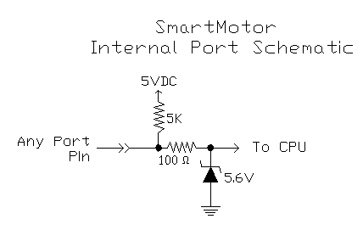
Note: At any time, regardless of usage, the ports may be read as an analog value.

I/O Port Hardware

Each I/O point has a 100 Ohm series current
limit resistor with a 5Kohm pull-up.
Each has a 5.6VDC Zener diode as well.
Each can sink 15mA and source 4mA.

NOTE: They are not open collector P or N type outputs! They are Totem Pole CMOS driven outputs. When assigned as outputs they drive hard to either 5VDC or Ground
when set to a 1 or 0 respectively

It is possible to use an Open Collector NPN type 24VDC prox with the SmartMotors.

The Use of PNP sourcing type 24VDC prox switches will damage the SmartMotor!

Dry contacts, if used, should be wired from the port pin to ground.
If you wire them from the port pin to 5VDC, the pull up resistor will cause you to always see a logic 1 on the port.

back to top

Software Control of I/O Ports

This is an overview of SmartMotor Code to control the on-board I/O:
In each case, X denotes any port A through G and should be replaced with the port letter to be used.

Reading a Port as an Input:

UXI : defines port "X" as an input port; X is any port A-F

Example:
UAI would define port "A" as an input port.

back to top

Software Control of I/O Ports (continued)

Assigning Port status to a variable:

x=UXI : assign the variable "x" the value at port "X".

: x will equal “1” if the port is at 5VDC.
: x will equal “0” if the port is at 0VDC.
: x can be any variable a-z, aa-zz, aaa-zzz..

Example: y=UAI would assign the logic state of port A to the variable y.
back to top

Reading a Port as an Analog value:

x=UXA : assigns the variable "x" a 10 Bit analog value from 0 to 1023 where 0 VDC=0
and 5VDC=1023
This command reads the selected port via a 10BIT A/D converter.

Example: z=UBA would assign the 10-Bit analog value of port B to the variable z.

Note: This is useful for self-diagnostics. By placing a known voltage dropping resistor on an external switch or other device, you can use the port as a general input, and yet do an analog read to check if the switch or sensor wire may have become disconnected from the port.
back to top

Assigning a Port as an Output:

UXO : defines port "X" as output port

Example: UEO would assign port B as an output.

UX=1 : drives voltage on port "X" to 5 VDC

Example: UE=1 would set port E to 5VDC.

UX=0 : drives voltage on port "X" to 0 VDC

Example: UE=0 would set port E to 0VDC.

Note: You can pre-define the state of a port prior to assigning it as an output.
Then you can toggle it between input and output to change from a driven state to a floating state. This is useful when tying I/O together between different SmartMotors.

back to top

Default States and special uses of I/O ports

Ports A and B Defaults and Specifics:

Ports A and B as quadrature encoder inputs:

Default state: Ports A and B default to phase A and B Encoder Inputs.
If no Port Control commands have been issued to Ports A or B, at any time,
you can use the CTR command to get counter values from these ports:

Example: RCTR would report counter status from ports A and B

x=CTR would assign the counter value to the variable x

MF0 would re-set the counter to zero. (Mode Follow Zero)

Using MF1, MF2, MF4 or MFR will allow you to make use of ports A & B as quadrature encoder input ports and place the Motors into Electronic gearing or Mode Follow.
See Help files or manual for more.

Ports A and B as Step and Direction inputs:

The MSO command re-sets the counter to zero and sets up Ports A and B as Step and Direction inputs respectively. Once doing so, the same rules apply as listed above for the RCTR and CTR commands.

Setting up the motor as a stepper via MS, MS0, or MSR command will make port A be a step input and port B a direction input as well.
See Help files or manual for more.

Note: MS0 command is a good way of using port A as a high speed counter It zeros the Counter without changing the motor’s mode of operation. From that point on, RCTR can report counts from prox switches, laser scanners etc.. as a high speed counter.

back to top

Default States and special uses of I/O ports (continued)

Ports C and D Defaults and Specifics:

Ports C and D default to right and left limit inputs respectively. If they are assigned as input or output ports, they must be redefined as limit switch inputs if you want them to be used as such. To redefine them as limit inputs you do the following:

Example: UCP redefines port "C" as right limit input (P for plus rotation)
UDM redefines port "D" as left limit input (M for minus rotation)

Note: BRKC Command has been added in later V4.15 and >=Versions 4.76 firmware.
This allows Port C to control and External brake via brake control commands.
See also: BRKSRV, BRKTRJ, BRKENG, BRKRLS
and the V4.76 Firmware document for more details.

Ports E and F Defaults and Specifics:

Ports E and F can be used as the Anilink port or an RS-485 port. Any command used for communication to Anilink
devices will automatically set the ports as needed for Address and Data information.
Using the OCHN and OCHR commands with regards to RS-485 usage will automatically set the ports to half duplex RS-485 operation.
See Help files or manual for more.

Ports G Defaults and Specifics:

By Default, when port G sees a transition from 5 to zero volts, it means the same as typing a "G" and pressing enter or seeing a G in a program. This is why it is called the G Sync pin.
This allows you to synchronize “goes” on multiple motors at the same time.
The G Port can be redefined as general I/O like the other ports.
UG : command returns Port "G" to default sync port so if you assigned it as an input or output, To redefine it as "G sync" simply invoke the UG command again.

Port G also has the option of being used as a handshake line for RS-232 to RS-485 Adapters.
This is covered in the Help Files and manual under communications.

Note: BRKG Command has been added in later V4.15 and >=Versions 4.76 firmware.
This allows Port G to control and External brake via brake control commands.
See also: BRKSRV, BRKTRJ, BRKENG, BRKRLS
and the V4.76 Firmware document for more details.

back to top

I/O Programming examples

The following are examples of triggering events off of Port I/O state changes.

Level Triggered Subroutine call

This code causes subroutine 100 to be called when port A goes high

IF UAI==1
GOSUB100
ENDIF

Positive-Edge-Triggered Subroutine Call

This code causes subroutine 100 to be called when port A goes high
only after first going low (negative pulse triggered subroutine call)

IF UAI==0
WHILE UAI==0
LOOP
GOSUB100
ENDIF

Negative-Edge Triggered Subroutine Call

This code causes subroutine 100 to be called when port A goes low
only after first going high (positive pulse triggered subroutine call)

IF UAI==1
WHILE UAI==1
LOOP
GOSUB100
ENDIF

Level and State Change Print-Out example

WHILE 1==1 ‘while forever

WHILE UBI==1 LOOP ‘while port B is high, do nothing

PRINT(“Port B just went Low”,#13)
PRINT(“Do nothing while it is Low”,#13)

WHILE UBI==0 LOOP ‘while port B is low, do nothing

PRINT(“Port B just went High”,#13)
PRINT(“Do nothing while it is High”,#13)
LOOP
back to top

