

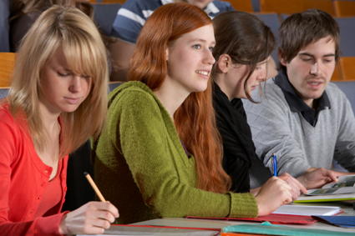
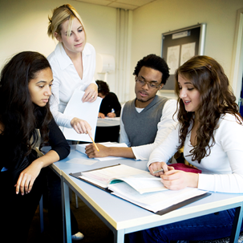
College of Applied Sciences & Arts

SAN JOSÉ STATE UNIVERSITY

the College of Applied Sciences and Arts (CASA)
Student Success Center

Located on the 5th floor of MacQuarrie Hall, Room 533
Ph#: (408) 924-2910
Writing Specialist - Here
to Help, Beginning Feb. 2!

30-minute Drop-in Appointments available:

Wednesdays: 11am – 12:30pm
Fridays: 9am - 11:30am

Follow the CASA Student Success Center on Facebook!
This service is wheelchair accessible. Individuals needing other accommodations, please call us at (408) 924-2910.

