Prebiotic materials from on and off the early Earth
(presented to the Royal Society on Feb 13th, 2006)
Max Bernstein and the Astrochemistry Lab
Mail Stop 245-6
NASA Ames Research Center
Moffett Field, CA 94035-1000 U.S.A.
www.astrochem.org

Abstract: One of the great puzzles of all time is how did life arise? It has been universally presumed that life arose in a soup rich in carbon compounds, but from where did these organic molecules come? In this talk I will review proposed terrestrial sources of pre-biotic organic molecules such as Miller-Urey synthesis (including how they would depend on the oxidation state of the atmosphere) and hydrothermal vents and also input from space. While the former is perhaps better known and more commonly taught in school, we now know that comet and asteroid dust deliver tons of organics to the Earth every day, so this flux of reduced carbon from space probably also played a role in making the Earth habitable. We will compare and contrast the types and abundances of organics from on and off the Earth given standard assumptions. Perhaps each process provided specific compounds (amino acids, sugars, amphiphiles) that were directly related to the origin or early evolution of life. In any case, whether planetary, nebular, or interstellar we will consider how one might attempt to distinguish between abiotic organic molecules from actual signs of life as part of a robotic search for life in the Solar System.

Introduction

Coming after Professor Thaddeus’s gas-phase interstellar molecules but before Professor Grady’s planetary carbon cycle means that, in a way, I stand between Earth and sky. It may sounds rather mythic to say it that way, but given that the question of how life emerged on Earth is a subject that has inspired a great deal of myth, both scientific and otherwise, it is difficult to resist the temptation to be just a bit fabulous. In fact, I am
going to start with a creation story from the Kojiki - Japan's 8th century chronicle that starts with the formation of the world, deities, and Japan. I’ll leave the specifics of the island of Japan to the geologists, and the deities to subsequent speakers who are even more outrageous than I, and restrict myself in this talk to the world.

Fig 1. Cover art for an album called 'The
Kojiki' by Kitaro, 1990 Geffen Records.

"Before the heavens and the earth came into existence, all was a chaos, unimaginably limitless and without definite shape or form…out of this boundless, shapeless mass something light and transparent rose up and formed the heaven…(and a god emerges here)…In the meantime what was heavy and opaque in the void gradually precipitated and became the earth, but it had taken an immeasurably long time before it condensed sufficiently to form solid ground…" (1)

All things considered this excerpt from the Isobe translation of the Kojiki is remarkably similar to how we currently describe the Earth forming within the Solar nebula that came from the collapse of a vast dense interstellar cloud. Stars like the Sun and the clouds that precede them are composed primarily of the 'light and transparent' elements Hydrogen and Helium which escape (at least from the forming terrestrial planets) leaving behind the heavier elements that comprise the rocky planets of the inner Solar System. However, exactly how and when the 'something light and transparent rose up' - which I interpret to mean 'when did the hydrogen escape if it ever was there to begin with?' or 'What was the oxidation state of the early Earth's atmosphere?' - has important consequences for how complex and profuse one expects organic compounds to be on the early Earth (2). And the abundance of organic molecules on the early Earth is the first crucial matter we must address this week in our discussions of conditions for emergence of life on the early Earth because, as we shall see, all non-magical notions of how life emerges are predicated on the presence of organic compounds, as well as some other substances that we know make up living things today.

My apologies to the impatient chemists for not just jumping right into the organic chemistry here but I can hardly discuss the conditions necessary for the emergence of life on the early Earth (in my case chemical conditions) without at least briefly presenting some of the ideas about how life emerged on Earth, which will set the requirements. Incidentally, it seems to me that the conditions under which life first developed might well be much more restricted than those under which life can survive or thrive thereafter, so I am going to assume that terrestrial life did, in fact, first begin here on the Earth and was not transported (or deliberately set down) here. Presumably if any of you favor some kind of panspermia, at least you will find my conditions hospitable, if a bit provincial.

So, lets briefly consider the first of these non-mythological conceptions of how life emerged as an example, and then proceed to experimental tests of that concept. The prototypical example comes from a private letter Charles Darwin wrote in 1871 in which he speculated about how
"…we could conceive in some warm little pond with all sorts of ammonia and phosphoric salts, light, heat, electricity, etc. present, that a protein compound was chemically formed, ready to undergo still more complex changes. At the present day, such matter would be instantly devoured or absorbed which would not have been the case before living creatures were formed." (3)

It need not be a protein of course, but it was a logical choice since Strecker had shown in the 1850s that one could make amino acids by heating an aqueous solution of simple starting materials (4). It is easy to forget that they did not know about nucleic acids, and besides, the kind of molecule doesn't matter here in Session 1 on Monday. The important part is that one goes from a random mix of essential but disordered components to the first self-replicating molecule, and from there to the last common ancestor is a simple matter of natural selection. From the 1920s onward A. Oparin and H.B.S. Haldane publicly presented and more fully developed similar ideas of a primordial soup (5) but the kernel of the idea was there back in that private letter of Darwin's in 1871. In other

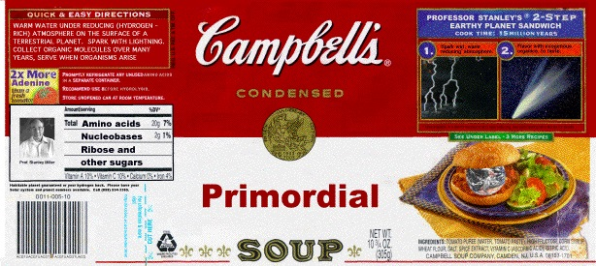
Fig 2. The primordial soup, now available in cans.
words, scientific origins of life scenarios tend to put the pieces of life in proximity to one another, add some kind of energy, and figure that eventually something or some process that can reproduce itself will arise. In session three, I think, Profs. Szathmary and Ferris will speak about how a self-replicating molecule may have arisen, and Profs. Wachterhauser and Deamer on alternatives to focusing on such a molecule, and I am very much looking forward to all of those lectures. My job, thankfully is so much easier than theirs. What I want to consider in my talk is where those pieces might have come from.

Spark discharge – Lightning in a reducing atmosphere

It's a given that one can presume that the early Earth would have had an atmosphere of simple gases of the type seen in space, or other planetary atmospheres, and/or predicted to be present based on models of how the Earth formed. Then, with these simple gases you see if you can make biotic or prebiotic monomers by adding energy. Miller's spark discharge experiments (6) were probably the first and certainly the most famous modern experimental attempt of that kind to make the primordial soup about which Darwin, Oparin and Haldane had written. The landmark Miller-Urey experiments, showed how those first components of the first self-replicating molecule could easily be made by cooking up a little early Earth in a flask. The experiment consisted of running sparks (lightning) into a glass sphere [Fig. 3] containing a reduced (2) gas mixture of simple molecules such as hydrogen, ammonia, and methane (the atmosphere) connected by a tube to a reservoir of warm liquid water (the ocean).

The results were breathtaking. When Miller analyzed the organic matter that was made in that and subsequent experiments he found certain amino acids and nucleo-bases, just the kind of thing that would have delighted Darwin. Starting with some simple common gases, a fairly minimal apparatus, and a little energy, the fundamental components of proteins and DNA, had formed rapidly. Although he was among the first to tackle the problem experimentally, and had only just begun, Miller had already made tremendous progress. Given that it was also the year that the structure of DNA was published, I am told that it seemed as if the secrets of life were being revealed and that very soon scientists would understand how life had come about. It turns out, of course, that the situation is not quite so straightforward as it may have appeared at that time. For one thing, the assumption that a mixture of reduced gases accurately represents the atmosphere of the early Earth has since been called into question.
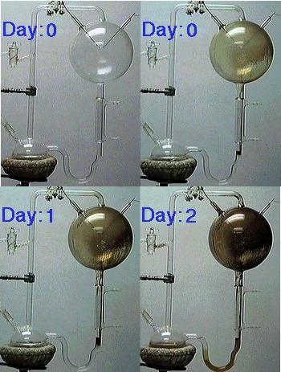
Fig 3. The kind of experimental apparatus used by Staney Miller to perform his landmark early Earth simulation experiments invovling the spark discharge of a reducing gas mixture. This image was given to me by Dr. Jason Dworkin who was a graduate student of Prof. Miller at UCSC. See reference 6 for details.

At the time, scientists believed that Jupiter was a good model for how planets began and that the early Earth formed warm and wet and had a thick atmosphere composed of reduced gases like hydrogen, methane, and ammonia left over from the formation of the Solar System. They figured that Earth's atmosphere, and that of all the planets, started with essentially solar abundances of gases, and they gradually escaped, as described in the Kojiki, leaving behind the N₂ that makes up most of our atmosphere today. Our oxygen came later, of course, as a waste product of life. Apparently part of the appeal of this reduced atmosphere for the early Earth was that it would have been a greenhouse mixture, keeping the Earth from freezing over during a period when the Sun was dimmer than it is today (7).

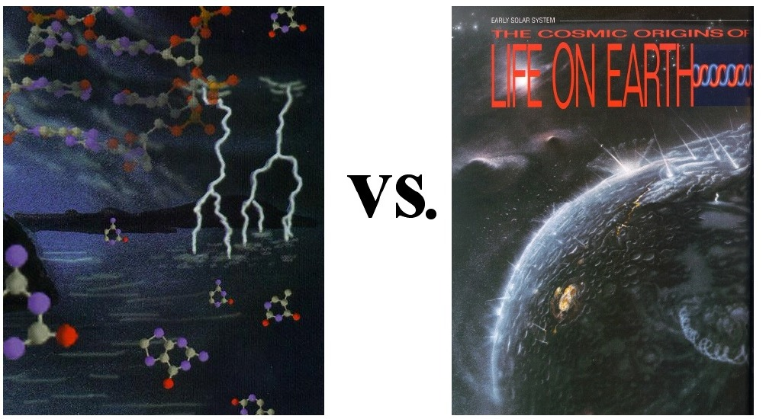
Figure 4. Artists representations of the contrasting conceptions of conditions on the early Earth. At left lightning strikes a warm water ocean beneath a thick reducing atmosphere and organic molecules are abundant. At right the early Earth as a barren rock where reduced compounds are relatively rare and the atmosphere will not accumulate until later. These are both extreme views and the reality was probably in-between. The former is from the cover of Sky and Telescope July 1997, and the latter from the November 1992 Issue of Astronomy magazine.

Jupiter retained its original gases because it is so massive that the molecules could never escape. But size is not the only difference between Jupiter and the Earth, we are also much closer to the Sun. The notion that, from the time of formation, the Earth started with a thick Jupiter-like atmosphere was seriously undermined by models showing that the temperature in the Solar nebula here at 1 AU exceeded 1000 K (8). If true then the Earth formed hot and relatively devoid of atmosphere as a result, and subsequent impacts didn't help any either (9). Instead of being a kind of gaseous placena, our atmosphere is thought to have accumulated about the planet thereafter by outgassing (10) from the Earth. When a Mars-sized object collided with the Earth leading to the formation of the moon (11) that must have blown away any atmosphere or ocean that the earth had built up during those tens of millions of years after planet formation (9). Continued outgassing punctuated by the occasional giant impact led to an atmosphere, but one very different from that of Jupiter in both its manner of formation and also its composition.

Geologic data suggested that the earth has been at or near its current oxidation state for over three and probably close to 4 billion years (12) implying an atmosphere composed of neutral or perhaps even oxidized gases such as H₂O, CO₂, and SO₂. Such an oxidizing mixture on the early Earth would make it very difficult to make organic compounds like amino acids, by spark discharge (13). My understanding is that while most agree that the atmosphere was not reducing (14), on the other hand there is not a consensus that it was totally oxidizing either. Last year there was a report asserting even if the early atmosphere were dominated by CO₂, the rate of escape of hydrogen from the Earth had been overestimated, so more molecular hydrogen would have accumulated in the Earth's atmosphere than was previously thought (15). This hydrogen in turn would have allowed for some terrestrial synthesis of organic compounds (as simulated by spark discharge) albeit much less efficiently than with the original Miller gas mixture (13).

Hydrothermal vents

In any case, if the spark discharge method of making organic molecules is not quite as important as was originally thought, there are many other ways in which organic molecules may have formed on the early Earth. One very logical approach is to follow the hydrogen. After all, even if it turns out the early atmosphere was not Jupiter-like, one might still find a place where the conditions are fairly reducing and therefore organic synthesis should be possible. Perhaps the most popular sites for potential organic synthesis in this vein are hydrothermal vents, and with good reason. Reducing gases emerge there, at least today, and presumably the early Earth was even more tectonically active than today, so there would have been a great many of them early on.

Personally I think that hydrothermal synthesis enjoys a certain psychological advantage over gas-phase syntheses since humans are used to thinking about reactions in hot liquid, that’s why the notion of the primordial ‘soup’ is so popular. Be that as it may, the laboratory experiments simulating the conditions in hydrothermal vents have been very promising, yielding a lipids and related compounds (16) amino acid formation (17) and oligomerization (18) nucleotide oligomerization (19) and pyruvate (20). A caveat on this subject: Smirnov and Schoonen (21) warn that stainless steel, which has sometimes been part of these laboratory equipment, can act as a catalyst for certain reactions under hydrothermal conditions, so one has to pay attention to experimental details. This obviously only a cursory glance at this subject, please see Holm and Andersson for a recent review. (22)

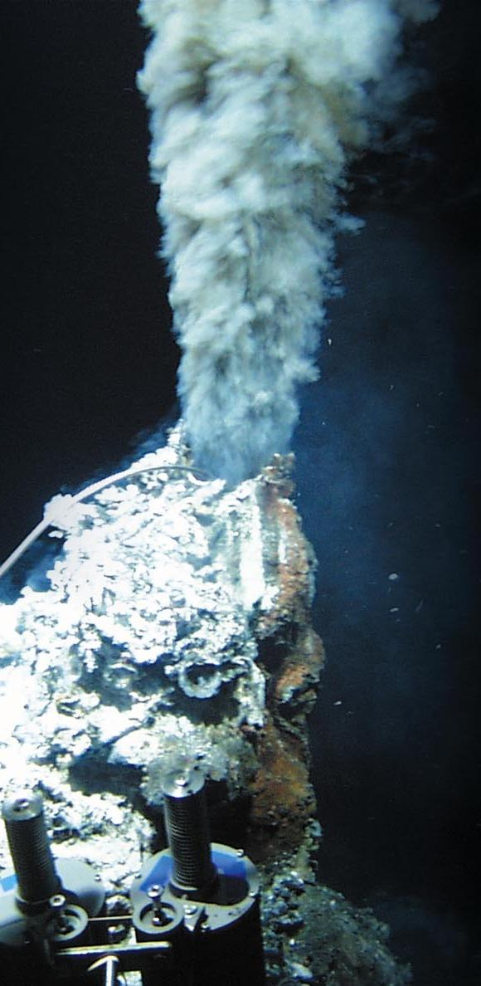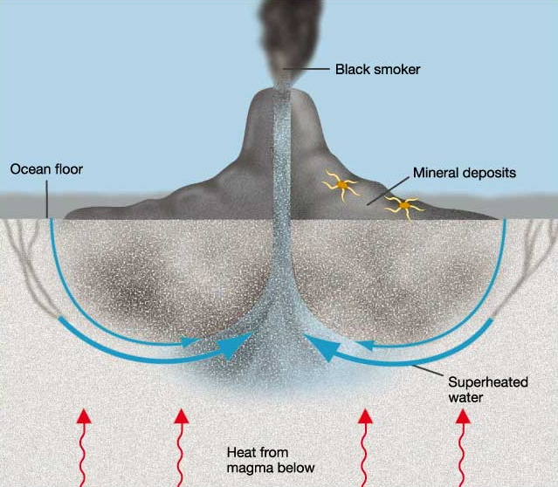
Figure 5. Left: an image of a smoker from the Lost City hydrothermal vent field from the University of Washington (www.washington.edu/newsroom/news/images/lostcity/)
At right: schematic of circulation of sewater through a hydrothermal vent from the University of Illinois at chicago (www.uic.edu/classes/bios/bios100/summer2002/blacksmoker.jpg).

In addition to being a potential locally reducing environment, hydrothermal vents are also a good site for pre-biotic organics because of they way that they are perched upon gradients. I suspect that subsequent speakers may touch on this and probably could explain this far better than I but, briefly, a gradient is a wonderful place to make or maintain things that are not really stable in the thermodynamic big-long-run-picture, like us or anything else alive. By all thermodynamic rights we should all really be CO₂ and H₂O, rather than what we are, and it is under such temporary kinetic conditions that organic molecules and life survive. Like a scalding kiln against the far wall of a pottery studio where things can be heated until set, but then are removed and put aside to cool, the hot interior of the vent is an enclosed hot place where molecules are presumably made and then flow out into the surrounding water to cool. Avoiding an extended stay in the hot water that would surely hydrolyze our putative newly formed protein (or whatever) is important to the success of the laboratory experiments that demonstrate the potential of hydrothermal vents for pre-biotic chemical synthesis. In practice, building up oligomers in the laboratory involves cycling the solution round and round through the heated synthetic chamber and the cooled quench, and presumably this is representative of the cycle of water around hydrothermal vent systems [Figure 5].

The cycling of synthesized organics into a cooler environment where they are more stable deals nicely with one of the objections that has been raised to the warm pond: that while one might be able to build up a biopolymer like a protein there, the abundant water that is all around this protein will, eventually and inevitably, add to the peptide bonds and break it down, and the warmer the faster. (23) Putting proteins in warm water is, after all, what we do to cook them, and keeping them cool in the fridge is what we do to preserve them.
Taking this to the logical extreme we should consider organic synthesis at very low temperatures, since our pre-biotic organics will survive there. As water freezes it concentrates solutes just like an evaporating pond, but avoiding the break down of potential biopolymers that automatically comes with elevated temperature. The problem, of course, is that while the molecules that you have made do last longer, the reactions that synthesize these molecules go slower at low temperature too, so one must be patient. The chemists rule of thumb is a factor of two or three for every ten degrees Celsius, so between boiling and freezing pure water the difference in rate should be in the range 2¹⁰-3¹⁰ (~10³-10⁵). In what must hold the record for the longest experiment ever published, Stanley Miller and co-workers published a report on the prebiotic synthesis of purine and pyrimidine bases from a dilute solution of ammonium cyanide solution frozen at –78 C for 27 years! (24) Similarly, but less dramatically it had been shown previously that hydroxy, amino and carboxylic acids can be formed in aqueous solutions at –10 C. (25)

Whether it is spark discharge experiments intended to simulate lightning in the atmosphere, or evaporating ponds, or hydrothermal vents, or freezing solutions, there are various ways to make pre-biotic organic molecules, and they all seem to be reasonable, to various extents, depending on what one believes of the early Earth. Depending on the oxidation state of the atmosphere, the prevalence of hydrothermal vents, or whether or not the earth had enough greenhouse gases to avoid freezing over, either one or another of the processes mentioned will allow for the synthesis of some organic molecules. In addition to all of these terrestrial sources of organics there is another one too; we know that tons organic molecules from space are swept up by the Earth every day (26), and perhaps these molecules played a role in making the planet habitable (27).

Extraterrestrial input

In Hollywood and among dinosaur obsessed children, the best-known way that extraterrestrial matter comes to earth is in the form of a large comet or asteroid that has to be deflected by Bruce Willis or it will release a tremendous amount of energy leaving mayhem and thermal decomposition of organic molecules in its wake. One’s intuition might suggest that such events are only destructive but that is not the case. Not only can compounds survive such impacts, (28) such cataclysms, too, are an opportunity for organic synthesis. Calculations suggest that locally, an impactor can create an environment conducive to the synthesis of reduced carbon compounds by Fischer-Tropsch type reactions (29, 30). In addition, experiments have shown that hypervelocity impacts will oligomerize amino acids monomers. (31) and make other organic molecules. (32)

Despite the drama of the aforementioned big bolide impacts, most matter from space that comes to the surface of the earth is in the form of micron sized comet and asteroidal dust, (a.k.a. Interplanetary Dust Particles or IDPs; Figure 6). Since there was a lot more debris
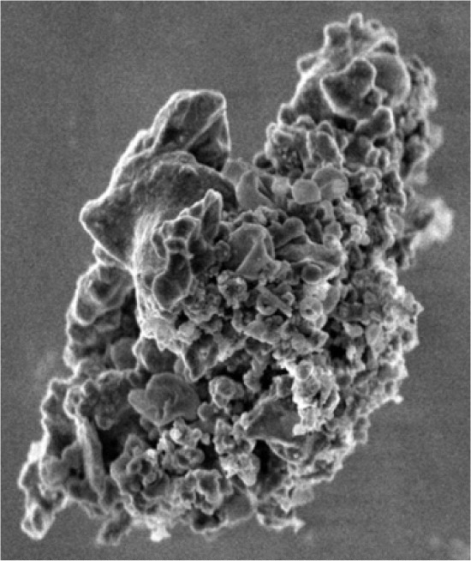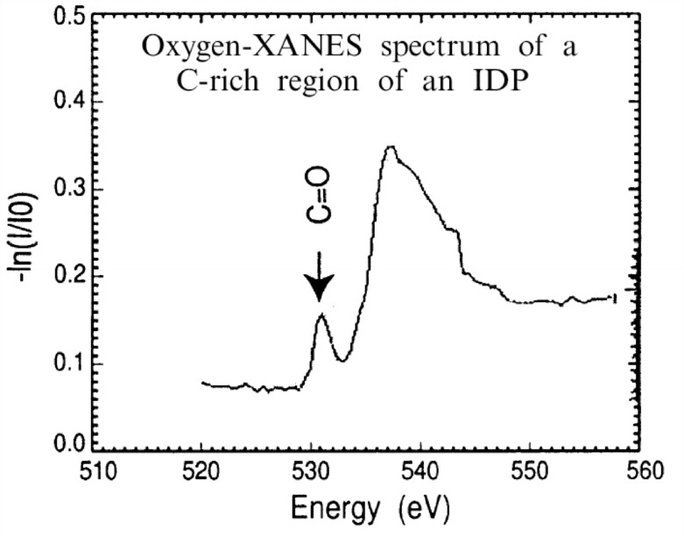
Figure 6. A Scanning electron microscope image of L2021C5, an ~10 μm IDP (left) and an oxygen Xanes spectrum showing the presence of carbonyl functional groups estimated at the percent level (right). These particles can contain over 90 vol% of carbon. From Flynn et al., (reference 33).

floating around the early Solar System there was, perhaps, a million times more matter falling onto the early Earth than there is today (30). This would imply a pre-biotic source of organic compounds that would rival or exceed that produced by a Miller-type synthesis using a CO₂-H₂ atmosphere (13, 15), but it depends on how much dust one thinks there was 4 billion years ago. But perhaps there is more to it than just reduced carbon, maybe the compounds that are delivered actually matter, so lets take a look at them.

Some infrared (33) and mass spectra (34) of IDPs exist, and new techniques are being developed for the analysis of comet dust from the Stardust mission, but our knowledge of the organics in IDPs are limited by their microscopic size. Far more is known about the carbon compounds in meteorites, and they are also thought to derive from comets and asteroids so it is assumed that the organic molecules in IDPs resemble those in meteorites. In both cases most of the carbon in meteorites is in the form of a complex, insoluble, coal-like macromolecular network of reduced carbon, sometimes called ‘kerogen’ in analogy with terrestrial biotic detritus for which this name is generally reserved. This macromolecular matter dominated by hydrocarbons, both aromatic and aliphatic, but is not composed solely of carbon and hydrogen. Oxygen is common, nitrogen is present, and there are often deuterium enrichments and other isotopic anomalies.

There are some known differences between the organics in IDPs and meteorites though. For one thing, carbon-rich meteorites have just a few percent organic carbon, a factor of 10 less than IDPs which can be up to 50% organic carbon by mass. For another, the meteoritic kerogen carries more oxygen than does the carbon in IDPs. Solid state NMR data suggests that roughly one in ten carbon atoms in meteoritic kerogen has a double bond to oxygen (C=O) such as a ketone or acid (35), but IR spectra of IDPs are consistent with only a percent or two C=O. (27) Perhaps the measurements of IDPs and meteorites, which rely on different methods, are not really comparable, i.e., there is no real difference. Maybe this comparison is telling us that even if they had a common source the suite of organics in IDPs and meteorites really are different either because of a strong bias in what matter goes into each, or something preferentially depleted meteorites of pure hydrocarbons, or oxidized them. Whether or not this difference in O/C ratio is real, or is connected to total carbon content, I will blithely continue to use meteoritic molecules as representative of what was available on the early Earth.
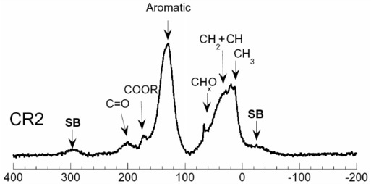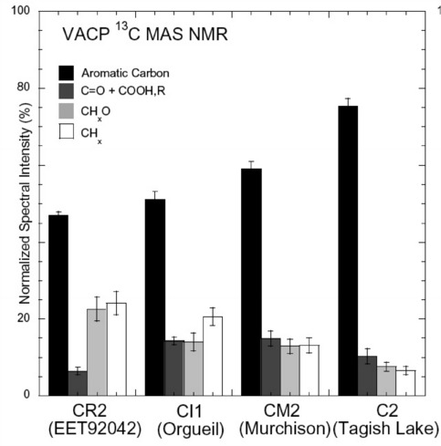
Figure 7. NMR spectrum (left) and bar graph (right) indicating a substantial amount of the carbon (i.e., ~8% of the total) is in the form of a carbonyl (C=O). From reference 35.

Extractions have shown that carbon-rich meteorites contain abundant individual soluble molecules of prebiotic interest including hydroxy-, imino-, keto- and amino acids (36), nucleobases and other N-heterocycles (37), simple sugar-like polyols (38) and fatty acids (39), as well as many other classes of compounds (23, 40). These are exactly the kinds of compounds that Darwin, Oparin and Haldane would have been happy to use to flavor the primordial soup, and they come ready made to the earth from space. It is possible that all of these extraterrestrial molecules are subducted, torn apart or otherwise recast by terrestrial processes, and this organic matter from space is simply a source of reduced carbon. However, its equally possible that the delivery of a particularly rich meteorite to a small pond, or a heavy shower of IDPs at an opportune time provided a compound that survived and was useful in some way. For example, the fact that more than one (non-biological) amino acid in more than one meteorite shows a bias towards the left handed form (41) inevitably makes me wonder whether there might have been some direct connection between the meteoritic tendency for left and the fact that left handed amino acids dominate in living things. Or, perhaps the fatty acids from Murchison that self-assemble into bi-layer vesicles (39) provided the first self-replicating molecule with the sequestration that it needed to avoid being taken advantage of by cheaters. (42)

Extraterrestrial synthesis

Whatever the role that they played, a rich suite of organic molecules were and are brought to the Earth from space by bits of asteroids and comets, large and small. Where do these compounds come from? A meteorite is a complex thing with materials and modifications overlaid from a series of different eras. Proceeding in reverse chronological order, first of all many extraterrestrial materials show evidence of having seen liquid water before they arrived at earth (43). This is consistent with models that show that if the parent asteroid or comet from which the meteorite comes was large enough the heating from decay of radionuclides could lead to long periods where liquid water is stable, and this could have important implications for organic chemistry. (44) Indeed, it is thought that most of the amino acids found in meteorites derived from reactions in liquid water on the parent body. (45)

Figure 8 – From the outflows of dying stars, reactions and radiation in the interstellar medium, through nebular and Solar System chemistry, to impacts and planetary processes like lightning and hydrothermal vents, there are myriad ways to make and modify carbon compounds as long as conditions are not terminally oxidzing. Figure credit, Jason Dworkin from Deamer et al (2002), reference 39.

However, one cannot explain all of the compounds in meteorites this way; some don't look like the kind of thing that forms in liquid water - hydrocarbons for instance. The abundance of surfaces, high temperatures and the abundance of hydrogen in the solar nebula should drive Fischer-Tropsch (F-T) type chemistry that would reduce CO or CO₂ to CH₄ and N₂ to NH₃. CH₄ and NH₃ are great starting materials for making more complex organics, but the highly branched structures that are common among meteoritic carbon compounds seem to be inconsistent with F-T being the dominant source of higher molecular weight organic matter. These meteorites contain inorganic and graphitic inclusions that are accepted as pre-solar (47) and as Dr. Thaddeus has told us, rotational spectroscopy has revealed a plethora of interstellar molecules, some fairly large, so why not assume there is an interstellar contribution to the organic material as well?

Perhaps the most convincing molecular evidence for the interstellar heritage of meteoritic molecules is their high deuterium (D) enrichment. (23, 48). At the low temperatures in dense molecular clouds deuterium fractionation is expected to be efficient and elevated D/H ratios have been seen in grain mantles (49) and several gas-phase interstellar molecules, including amino acid precursors, such as formaldehyde and ammonia (50). A reported observation of interstellar glycine in the ISM (51) and experiments showing the viability of a condensed-phase interstellar synthesis (52) suggest that some meteoritic amino acids formed before the Solar System, or perhaps a precursor amino-nitrile that was converted to the amino acid in liquid water (53). And the vesicle forming (39) meteoritic fatty acids (54) may also be of interstellar origin (55).

There are too many smaller interstellar molecules and too much work both theoretical and experimental on processes that lead to them (such as ion molecule reactions) for me to possibly review them here. This is a very limited and personal view, I make no claims at completeness but instead am just mentioning a few of the paths leading to pre-biotically more interesting molecules here. For those who are interested in knowing more I offer to lend you any of the books on my shelves that give greater detail. (56)

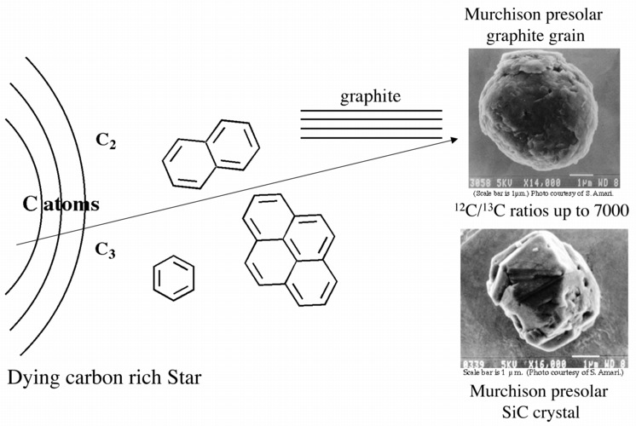
Figure 9. Carbon molecules first form around dying carbon rich stars, and some of this material survives incorporation into carbonaceous meteorites as indicated by the presence of isotopic anomalies.

But even with all of these options some problem structures still remain. While our laboratory experiments suggest that interstellar chemistry can explain why so many of the meteoritic aromatics bear oxygen atoms (57), and thus why the polar hydrocarbon fractions that contain them are deuterium enriched (58), the basic carbon skeleton is probably older. It seems that the initial carbon-carbon bonds, molecules and carbonaceous dust first formed around dying carbon rich stars (59) where the carbon atoms had been made in the first place [Figure 9]. Thus, the oldest chemical structures in meteorites date back, with interstellar or nebular modifications, to the previous generation of stars. Others formed in the interstellar medium, or in the solar nebula, or subsequently in the Solar System in an asteroid, an impact etc.

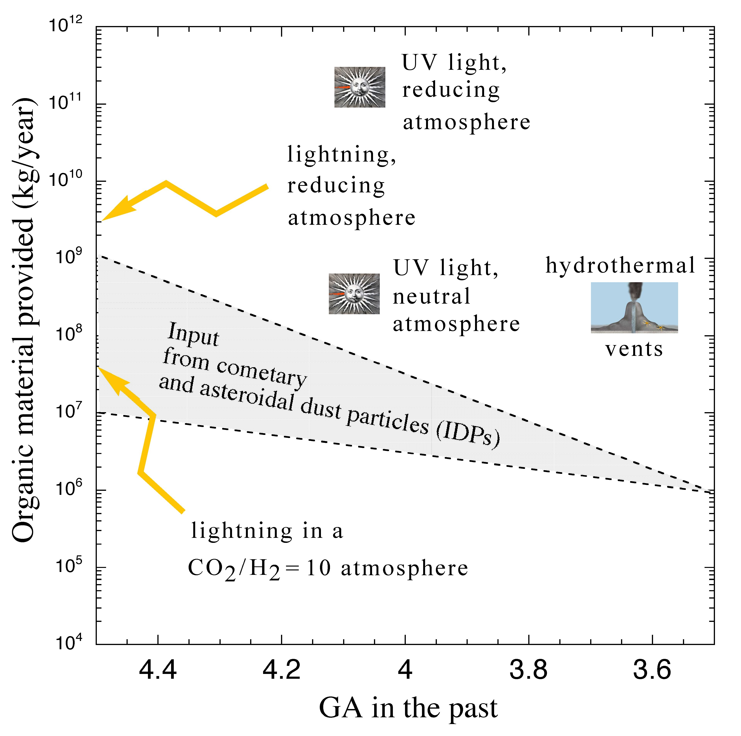
Figure 10. A visual representation summarizing the relative contributions of some major sources of organic molecules, both domestic and imported. The numbers are from citations 30 and 60, and the basic layout from a figure by S. L. Miller.

The relative contributions of organic matter to the prebiotic environment from on and off the early Earth are hard to assess because each of the processes we have mentioned are quite unconstrained. Terrestrial Miller-type synthesis depends on the oxidation state of the atmosphere, but if one assumes a CO₂ atmosphere then, depending on how much hydrogen was present, (13) the predicted quantities of organic matter would be roughly in the same very wide range as what might have come from comets (30) i.e., the equivalent of 10⁷-10⁹ Kg/year. How much complex organic material comes from hydrothermal vents is unclear. Vents are a bit different from the others in Figure 10 since the value of 1-3x10⁸ kg/year (60) in Figure 10 is simply methane, the starting material that is converted to complex organics by the other processes, such as lightning, UV etc. This value in Figure10 may be a bit out of date largely because of the relatively recent discovery of off-axis sites such as Lost City; if off-axis sites are very common then the above CH₄ estimate might be too low. (K. Hand, personal communication). That is, assuming that the extra CH₄ is not biological in origin, which it may be so I have used the more conservative older number. Presumably this value too would also vary greatly depending on oxidation state of the early ocean and how active one thinks the earth's surface and the hydrothermal flux was at that time. Chyba and Sagan (30) suggest that synthesis of organics by UV photolysis should actually be the largest source, but these numbers also seem to be the most uncertain. They are based on estimates of absorption cross-sections of different molecules at different wavelengths and vary by four orders of magnitude. The relative contributions of these different sources are summarized in Figure 10. Clearly, one way or another there were all kinds of interesting organic molecules present on the early Earth. I am looking forward to seeing what the following speakers will be able to do with them. But before then I would like to take you on a brief exobiology interlude.

Coda: The search for life in the Solar System

While I know that technically this is a side path off of the main route that we are to take this week it is hard for a NASA scientist to resist trying to use some of what has been learned from studies of the origin of life for the search for life in the Solar System. Many current approaches to the robotic search for life seem to be instrument driven, with proposals to employ ever more sophisticated but off the shelf biotechnology on landers and rovers to detect proteins and nucleic acids. However, the structures of terrestrial biomolecules were almost certainly different in the past, e.g., DNA is seems to be modern, (61) so there is no reason to think that alien biomolecules will be so similar to our own that devices designed for earthly life will work at all. The alternative bases (62), sugars (63), and backbones (64) that have come out of this community suggest how different life may have been on Earth and can help us keep an open mind when thinking about the most difficult cases we may face in the search for alien life.

What I mean by this is while we may get lucky and see a whale breaching on Europa we have to ask ourselves about what we shall consider biomarkers in the event that we end up being removed, either by millions of years or by kilometers of crust, from alien life. If only molecular fragments remain, and they don't look familiar, how will we be sure that we are looking at something that was once alive, as opposed to a prebiotic mix of amino acids, nucleobases and sugars? Obviously an oligomer of D amino acids would be a dead lock for alien life, such chirality and connectivity combined would be hard to imagine forming any other way. But how narrow would the spread in chain lengths of fatty acids have to be for you to believe that it was a biomarker? I have been wondering lately whether there is some molecular assemblage that was familiar in the classes of compounds but not the particular molecular components that could be a kind of generalized biomarker. Would any base attached to any sugar be convincing? What do you think of the flavin attached to the sugar in figure 11? What if it were added a phosphate Am I being too specific now? I will leave you with such questions to ponder and I am very much looking forward to your talks and being educated by what you have to say. Thank you.

Figure 11. Left, the chemical structure of a base-like molecule (a flavin) and a sugar covalently bonded together in analogy to that of the bases and sugars in our DNA such as that seen in the nucleotide of Thymine (at right). The sugar and base at the left are different than those on the right, but the basic classes are the same, as are the arrangement of the ketones in the upper right and the way the sugar is connected, so would it be a biomarker? (65)

Acknowledgements
I would like to thank Jason Dworkin, Kevin Hand, and Koichiro Matsuno for helping with making the 'new' version of figure 10. The original was made by Dr. Dworkin with numbers from and under the direction of Prof. Stanley Miller, who presented it as part of a talk at the 1993 ISSOL meeting. I would also like to acknowledge financial support from NASA’s Exobiology and Astrobiology programs, which allow me to spend time thinking about and performing experiments on prebiotic chemistry and biomarkers.

Notes

1. (Translated by Yaichiro Isobe from Reading About the World, Vol. I edited by Paul Brians, Mary Gallwey, Douglas Hughes, Azfar Hussain, Richard Law, Michael Myers Michael Neville, Roger Schlesinger, Alice Spitzer, and Susan Swan The third edition 1999 by Harcourt Brace Custom Publishing. Also on the web at: http://www.wsu.edu:8080/~wldciv/world_civ_reader/world_civ_reader_1/kojiki.html)

2. Defining 'organic' and 'reduced': When I refer to organic compounds, I mean those composed primarily of carbon, but may also contain nitrogen, oxygen and other elements. These are the kinds of molecules from which we and all living things are made, as opposed to carbon in the form of carbonate rocks, which is considered 'inorganic. ' Technically 'reduced' carbon is that bearing hydrogen atoms, such as in methane (CH₄). Oxidized carbon is that such as in carbon dioxide (CO₂) or carbonate rock, where all of the bonding is satisfied by oxygen atoms. For the purposes of being good pre-biotic molecules partially oxidized carbon species (e.g., ketones >C=O) will be of use in making bigger, more complicated, and biologically important compounds. A 'reduced' gas is rich in hydrogen, or compounds that bear hydrogen, such as methane (CH₄) and ammonia (NH₃). Reduced gas mixtures produce more complex organic molecules than do oxidizing ones which is why the oxidation state of the early Earth’s atmosphere is so important.

3. Letter to Joseph Dalton Hooker, February 1, 1871. Darwin F., (1898) The Life and Letters of Charles Darwin, Basic Books: New York NY, Vol. II, 1959, pp.202-203.

4. Strecker, A. Ann. 1850, 75, 27. Strecker, A. (1854) Ann., 91, 349.

5. A.I. Oparin, (1938) The Origin of Life, Translation with annotations by S. Morgulis Macmillan republished in 1953, 1965 and 2003 by Dover.

6. Miller, Stanley L. (1953) Production of Amino Acids under Possible Primitive Earth Conditions. Science, Volume 117, Issue 3046, pp. 528-529.

7. Presumed a reducing atmosphere which being a greenhouse mixture and would also prevent the Earth from having frozen over. (Sagan, C.; Chyba, C. (1997) The early faint sun paradox: Organic shielding of ultraviolet-labile greenhouse gases Science, 276, 1217-1221

8. Bell, K. R.; Cassen, P. M.; Wasson, J. T.; Woolum, D. S. (2000) The FU Orionis Phenomenon and Solar Nebula Material Protostars and Planets IV (Book - Tucson: University of Arizona Press; eds Mannings, V., Boss, A.P., Russell, S. S.), p. 897

9. Sleep, N. H., Zahnle, K., and Neuhoff, P. S., (2001) Initiation of clement surface conditions on the earliest Earth. PNAS., 98, 3666–3672.

10. K.A.FarleyandE.Neroda (1998) Noble gases in the earth’s Mantle Annu. Rev. Earth Planet. Sci..26,189–218
Turner G.(1989) Journal of the Geological Society,146, 147-154
CJ Allegre, T Staudacher, P Sarda (1987) Rare gas systematics - Formation of the atmosphere, evolution and structure of the earth's mantle Earth and Planetary Science Letters 81, 127-150.

11. Palme, H., (2004) Planetary Science Perspective: The Giant Impact Formation of the Moon Science 304, 977 - 979

12. Delano, J. W. (2001) Redox History of the Earth’s Interior Since ~3900 Ma: Implications For Prebiotic Molecules Origin of Life Evol Biosphere, 31, 311-341.

13. R. Stribling, S.L. Miller, Origins Life17, 261 (1987).

14. P.H. Abelson, Proc. Natl. Acad. Sci. 55, 1365.
J. C. G. Walker, Evolution of the Atmosphere (Macmillan, New York, 1977).
Kasting, J. F., Eggler, D. H., 10th ISSOL meeting, Round Table I, Mon July 1, 2002C.
F.Chyba Science (2005) 308, 962-963. http://www.sciencemag.org/cgi/content/summary/308/5724/962

15. Tian, Toon, Pavlov & Sterck, (2005) ‘A Hydrogen-Rich Early Earth Atmosphere’ Science 308, 1014-1017.

16. Rushdi, A.I. and Simoneit, B.R.T. (2001) Lipid formation by aqueous Fischer-Tropsch-type synthesis over a temperature range of 100 to 400°C. Orig. Life Evol. Biosph. 31, 103–118.

Thomas M. McCollom, Gilles Ritter and Bernd R. T. Simoneit (1999) ‘Lipid Synthesis Under Hydrothermal Conditions by Fischer- Tropsch-Type Reactions’ Orig. Life Evol. Biosph 29, 153–166.

17. Hennet, R.J.-C., Holm, N.G., and Engel, M.H. (1992) Abiotic synthesis of amino acids under hydrothermal conditions and the origin of life: A perpetual phenomenon? Naturwissenschaften 79, 361–365.

18. Islam, Md. N., Kaneko T. and Kobayashi K. (2003) Reaction of Amino Acids in a Supercritical Water-Flow Reactor Simulating Submarine Hydrothermal Systems Bulletin of the Chemical Society of Japan 76, 1171-1178.

Yokoyama, S., Koyama, A., Nemoto, A., Honda, H., Imai, E.-I., Hatori, K., Matsuno, K., Amplification of Diverse Catalytic Properties of Evolving Molecules in a Simulated Hydrothermal Environment (2003) Orig. Life Evol. Biosph, 33, 589-595.

Imai, E.-I., Honda, H., Hatori, K., Matsuno, K., (1999) Autocatalytic Synthesis of Oligoglycine in a Simulated Submarine Hydrothermal System Orig. Life Evol. Biosph, 29, 249-259.

19. Ogasawara, Hiroshi; Yoshida, Ayumu; Imai, Ei-ichi; Honda, Hajime; Hatori, Kuniyuki; Matsuno, Koichiro (2000) Synthesizing Oligomers from Monomeric Nucleotides in Simulated Hydrothermal Environments Orig. Life Evol. Biosph, 30, 519-526.

20. G. D. Cody N. Z. Boctor, T. R. Filley, R. M. Hazen, J H. Scott, A. Sharma, H. S. Yoder Jr. (2000) Primordial Carbonylated Iron-Sulfur Compounds and the Synthesis of Pyruvate. Science, 289, 1337-1340.

Cody, G.D., Boctor, N.Z., Hazen, R.M., Brandes, J.A., Morowitz, H.J., and Yoder, H.S. Jr. (2001) Geochemical roots of autotrophic carbon fixation: Hydrothermal experiments in the system citric acid, H₂O-(Fes)-(NiS). Geochim. Cosmochim. Acta 65, 3557–3576.

Cody, G.D., Boctor, N.Z., Brandes, J.A., Filley, T.R., Hazen, R.M., and Yoder, H.S. Jr. (2004) Assaying the catalytic potential of transition metal sulfides for abiotic carbon fixation. Geochim. Cosmochim. Acta 68, 2185–2196.

21. Smirnov, A., Schoonen, M. A. A. (2003) Evaluating Experimental Artifacts in Hydrothermal Prebiotic Synthesis Experiments. Orig. Life Evol. Biosph., 33, 117-127.

22. N. G. Holm E. Andersson (2005) ' Hydrothermal Simulation Experiments as a Tool for Studies of the Origin of Life on Earth and Other Terrestrial Planets: A Review.' Astrobiology, 5, 444-460.

23. Cronin, J. R. & Chang, S. in Chemistry of Life’s Origins (NATOASI) (eds Greenberg, J. M., Pirronello, V. & Mendoza-Gomez, C.) 209–258 (Kluwer, Dordrecht, 1993).

24 S. Miyakawa, H. J. Cleaves and S. L. Miller (2002) The Cold Origin of Life: B. Implications Based on Pyrimidines and Purines Produced From Frozen Ammonium Cyanide Solutions Orig. Life Evol. Biosph., 32, 209 – 218.

Levy, M., Miller, S.L., Brinton, K., and Bada, J.L. (2000) Prebiotic synthesis of adenine and amino acids under Europa-like conditions. Icarus 145, 609–613.

- Lerner N. R. (1995) Carboxylic Acids as Indicators of Parent Body Conditions Meteoritics, 30, 535.

26 Love, S. G.; Brownlee, D. E. (1995) A direct measurement of the terrestrial mass accretion rate of cosmic dust Science, vol. 262, p. 550-553

27. J. Oró T. Mills and A. Lazcano (1991) Comets and the formation of biochemical compounds on the primitive Earth – A review Orig. Life Evol. Biosph 21, 267 - 277

28. E. Pierazzo, CF Chyba (1999) Meteoritics & Planet. Sci. 34, 909-918,

29. Kress, M. E.; McKay, C. P. (2004) Formation of methane in comet impacts: implications for Earth, Mars, and Titan’ Icarus, 168, 475-483.

30. Chyba C, Sagan C. 1992 Endogenous production, exogenous delivery and impact-shock synthesis of organic molecules: an inventory for the origins of life. Nature 355:125–132.

31. Blank, Jennifer G.; Miller, Gregory H.; Ahrens, Michael J.; Winans, Randall E. (2001) Experimental Shock Chemistry of Aqueous Amino Acid Solutions and the Cometary Delivery of Prebiotic Compounds Orig. Life Evol. Biosph., 31, 15-51.

32. Mimura, K., (1995) Synthesis of polycyclic aromatic hydrocarbons from benzene by impact shock: Its reaction mechanism and cosmochemical significance Geochimica et Cosmochimica Acta, vol. 59, Issue 3, pp.579-591
Gerasimov, M. V.; Dikov, Yu. P.; Yakovlev, O. I.; Wlotzka, F. (2000) On the Possibility of Hydrocarbons Synthesis During an Impact 31st Annual Lunar and Planetary Science Conference, March 13-17, 2000, Houston, Texas, abstract no. 1259
Managadze, George G.; Brinckerhoff, William B.; Chumikov, Alexander E. (2003) Molecular synthesis in hypervelocity impact plasmas on the primitive Earth and in interstellar clouds. Geophysical Research Letters, 30, 51. CiteID 1247

33 Flynn, G. J.; Keller, L. P.; Jacobsen, C.; Wirick, S. (2004) An assessment of the amount and types of organic matter contributed to the Earth by interplanetary dust Advances in Space Research, 33, 57-66.

34 Clemett, S. J.; Maechling, C. R.; Zare, R. N.; Swan, P. D.; Walker, R. M. (1993) Identification of complex aromatic molecules in individual interplanetary dust particles Science, 262, 721-725.

35 Cody, G. D.; Alexander, C. M. O. (2005) NMR studies of chemical structural variation of insoluble organic matter from different carbonaceous chondrite groups. Geochimica et Cosmochimica Acta, 69, 1085-1097.

36 Kminek, G.; Botta, O.; Glavin, D. P.; Bada, J. L. (2002) Amino acids in the Tagish Lake Meteorite. Meteoritics & Planetary Science, 37, 697-701.
Pizzarello, Sandra; Cooper, George W. (2001) Molecular and chiral analyses of some protein amino acid derivatives in the Murchison and Murray meteorite. Meteoritics & Planetary Science, 36, 897-909.

37 Stoks, P. G., & Schwartz, A. W. (1982) Geochim. Cosmochim. Acta, 46, 309

Basile, B. P., Middleditch, B. S., & Oro´ , J. (1984) Organic Geochem., 5, 211

Pizzarello, S. (2001), Lunar Planet. Sci. Conf., 32, 1886

38 Cooper, George; Kimmich, Novelle; Belisle, Warren; Sarinana, Josh; Brabham, Katrina; Garrel, Laurence (2001) Carbonaceous meteorites as a source of sugar-related organic compounds for the early Earth. Nature, 414, 879-883.

39. Deamer, D. W. (1985) Boundary Structures are Formed by Organic Components of the Murchison Carbonaceous Chondrite.
Nature, 317, 792-795.
Deamer, D. W., Dworkin, J. P., Sandford S.A.,Bernstein M. P., Allamandola. L.J., (2002) The First Cell Membranes Astrobiology 2, 371–381

40. Sephton, M. A., (2002) Organic Compounds in Carbonaceous Meteorites. Nat. Prod. Rep. 19, 292-311.
Pizzarello, Sandra; Huang, Yongsong; Becker, Luann; Poreda, Robert J.; Nieman, Ronald A.; Cooper, George; Williams, Michael (2001) The Organic Content of the Tagish Lake Meteorite Science, 293, 2236-2239.

41. Cronin, J. R. & Pizzarello, S. (1997) Enantiomeric excesses in meteoritic amino acids. Science 275, 951–955
Pizzarello, S.; Huang, Y.; Fuller, M. (2004) The carbon isotopic distribution of Murchison amino acids. Geochimica et Cosmochimica Acta, 68, 4963-4969.

42. Szabo P, Scheuring I, Czaran T, Szathmary E (2002). In silico simulations reveal that replicators with limited dispersal evolve towards higher efficiency and fidelity. Nature, 420, 340-343.
43. Robert, F. & Epstein, S. (1982) The concentration and isotopic composition of hydrogen, carbon and nitrogen in carbonaceous meteorites. Geochim. Cosmochim. Acta 46, 81–95
44 Cohen, Barbara A.; Coker, Robert F. (1999) Modeling of Liquid Water on CM Meteorite Parent Bodies and Implications for Amino Acid Racemization Icarus, 145, 369-381
45 Peltzer, E. T., Bada, J. L., Schlesinger, G. & Miller, S. L. 1984 The chemical conditions on the parent body of the murchison meteorite: Some conclusions based on amino, hydroxy and dicarboxylic acids Advances in Space Research, 4, 69-74; Ehrenfreund, P., Glavin D. P., Botta, O., Cooper, G. & Bada, J. L. (2001) Proc. Natl. Acad. Sci., 98, 2138.
46. Prinn, R. G., (1993) Chemistry and evolution of gaseous circumstellar disks In: Protostars and planets III (A93-42937 17-90), p. 1005-1028.
Kress, Monika E.; Tielens, Alexander G. G. M. (2001) The role of Fischer-Tropsch catalysis in solar nebula chemistry Meteoritics & Planetary Science, 36, 75-92.
47. Ott, U., (1993) Physical and isotopic properties of surviving interstellar carbon phases In: Protostars and planets III (A93-42937 17-90), p. 883-902.
48. Kerridge, J. F. (1999) Formation and processing of organics in the early Solar System. Space Sci. Rev. 90, 275–288
49. Teixeira, T. C., Devlin, J. P., Buch, V. & Emerson, J. P. 1999 Discovery of solid HDO in grain mantles. Astron. Astrophys. 347, L19–L22
50. Turner, B. E. (2001) Deuterated molecules in translucent and dark clouds. Astrophys. J. Suppl. Ser. 136, 579–629
51. Kuan, Y.-J., Charnley, S. B., Huang, H.-C., Tseng, W.-L., & Kisiel, Z. 2003, ApJ, 593, 848
52. Bernstein, M.P., Dworkin, J.P., Sandford, S.A., Cooper, G. W., & Allamandola, L. J. (2002) Racemic amino acids from the ultraviolet photolysis of interstellar ice analogs. Nature 416, 401–403;
Munoz-Caro, G.M., Meirhenrich, U.J., Schutte, W.A., et al. (2002) Amino acids from ultraviolet irradiation of interstellar ice analogs. Nature 416, 403–406
53. Bernstein, M.P., Ashbourn, S. F. M., Sandford, S.A., and Allamandola, L. J. (2004) The Lifetimes of Nitriles (CN) and Acids (COOH) during Ultraviolet Photolysis and their Survival in Space, ApJ 601, 365-370.
54. Huang, Y.; Wang, Y.; Alexandre, M. R.; Lee, T.; Rose-Petruck, C.; Fuller, M.; Pizzarello, S. (2005) Molecular and compound-specific isotopic characterization of monocarboxylic acids in carbonaceous meteorites. Geochimica et Cosmochimica Acta, 69, 1073-1084.
55. Dworkin, J. P., Deamer, D. W., Sandford, S. A., & Allamandola, L. J. (2001). Self-Assembling Amphiphilic Molecules: Synthesis in Simulated Interstellar/Precometary Ices. Proc. Nat. Acad. Sci. 98, 815-819.
56. Hollenbach, D. J.; Thronson, H. A., Jr. 'Interstellar processes' Proceedings of the Symposium, NASA, American Astronomical Society, et al. Dordrecht, D. Reidel Publishing Co. (Astrophysics and Space Science Library. Volume 134), 1987, 819 p.

Minh, Y. C.; van Dishoeck, E. F. Astrochemistry: From Molecular Clouds to Planetary Systems, Proceedings of IAU Symposium 197, held 23-27 Aug 1999, Sogwipo, South Korea. Edited by Y. C. Minh & E. F. van Dishoeck, 2000.

ELO Bakes (1997), "The Astrophysics Evolution of the Interstellar Medium", Twin Press. 1997.

57. Bernstein, M. P., Moore, M. H., Elsila, J. E., Sandford, S. A., Allamandola, L. J. & Zare, R. N. (2003). Side group Addition to the PAH Coronene by proton Irradiation in Cosmic Ice Analogs Astrophys. J., 582, L25-L29.

Bernstein, M. P., Elsila, J. E., Dworkin, J. P., Sandford, S. A., Allamandola, L. J. & Zare, R. N. (2002). Side group Addition to the PAH Coronene by UV Photolysis in Cosmic Ice analogs. Astrophys. J 576, 1115-1120.

Bernstein, M. P., Sandford, S. A., Allamandola, L. J., Gillette, J. S., Clemett, S. J., & Zare, R. N. (1999). UV Irradiation of Polycyclic Aromatic Hydrocarbons in Ices: Production of Alcohols, Quinones, and Ethers. Science 283, 1135-1138.

58. Sandford, S. A., Bernstein, M. P., & Dworkin, J. P. (2001) Assessment of the Interstellar Processes Leading to Deuterium Enrichment in Meteoritic Organics Meteoritics and Planetary Science, 36, 1117-1133.

59. Jones, A.P., 'The Lifecycle of Interstellar Dust' pp 97-106 and Frenklach, M., Feigelson, E., 'Formation of Carbon Particles in Cosmic Environments' pp 107-118 both in From Stardust to Planetesimals (eds Pendleton, Y. J., Tielens, A.G.G.M.) ASP Conference Series, Vol. 122, 1997.

60. Elderfield and Schultz, Mid-ocean ridge hydrothermal fluxes and the chemical composition of the ocean, Annual Review Earth and Planetary Science 24 (1996) 191-224. The value is from the flux of CH₄ from Table 14.

61. Gilbert, W., 1986. The RNAworld Nature 319, 618.
G.F. Joyce, J.A. Doudna, T.R. Cech, P.B. Moore, T.A. Steitz (2002) The Antiquity of RNA-based Evolution Nature 418, 214-221
Dworkin, J.P., Lazcano, A., Miller S.L., (2003) 'The roads to and from the RNAworld' Journal of Theoretical Biology 222 127–134.

62. H. Liu, J. Gao, S.R. Lynch, Y. D. Saito, L Maynard E. T. Kool (2003) A Four-Base Paired Genetic Helix with Expanded Size Science 302, 868
J. Horlacher, M. Hottiger, V. N. Podust, Ulrich Hobscher, and S. A. Benner (1995) Recognition by viral and cellular DNA polymerases of nucleosides bearing bases with nonstandard hydrogen bonding patterns. Proc. Natl. Acad. Sci. 92, 6329-6333.

63. Eschenmoser, A., (1999) Chemical etiology of nucleic acid structure. Science, 284, 2118.

64. Orgel, L.E. (1998) The origin of life—a review of facts and speculations Trends Biochem. Sci., 23, 491-495
Nielsen, R. E., (1993) Peptide nucleic acid (PNA): A model structure for the primordial genetic material? Origins of Life and Evolution of Biospheres 23, 323 – 327.
Schwartz, A. W., Minimal requirements for molecular information transfer (1986) Advances in Space Research, 6, 23-27

65. In fact, if XX=phosphate in the molecule at left is flavin mononucleotide, which is part of biology as a component of Complex I of the electron transport chain. See for example Anderson, P. C., Mecozzi, S. (2005) Identification of a 14mer RNA that recognizes and binds flavin mononucleotide with high affinity Nucleic Acids Research 33, 6992-6999. Cool huh?

