ME 115 Finite Difference Lab

This lab must be completed individually, although you are welcome to speak with your friends if you are having troubles. All figures and the problem definition are from Incropera, F., and DeWitt, D., 2002, Fundamentals of Heat and Mass Transfer, 5th ed., John Wiley and Sons, New York.

A simplified representation for cooling in very large-scale integration (VLSI) of microelectronics is shown in Figure 1. A silicon chip is mounted in a dielectric substrate, and one surface of the system is convectively cooled, while the remaining surfaces are well insulated from the surroundings. The problem is rendered two-dimensional by assuming the system to be very long in the direction perpendicular to the paper. Under steady-state operation, electric power dissipation in the chip provides for uniform volumetric heating at a rate of . However, the heating rate is limited by restriction on the maximum temperature that the chip is allowed to assume.
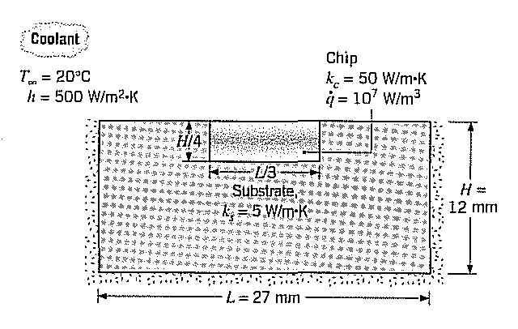
Figure 1 Schematic of VLSI cooling

a) For the chip shown, solve for the temperature distribution in the chip and substrate. A 1-mm grid spacing is recommended.

b) If the maximum chip (not substrate) temperature is 85°C, what is the maximum power density that the chip can dissipate? You can find this out by changing your q value until you find the one that gives the maximum temperature desired.

Steps:

1) Set up Excel to perform the iterations under “File”, “Options”, “Forumlas”. Set the calculation to manual, the maximum number of iterations to 10,000, and the maximum change to 0.00001. Check the box to enable iterative calculationis. The “maximum change” box tells Excel to consider your solution converged when the changes from one iteration to the next are less than 0.00001ºC. Turn off “Recalculate before save.” When you wish to calculate your results, hit F9. Always save before hitting F9! If you mistakenly enter an undefined number, it will spread throughout your spreadsheet once you hit F9, forcing you to start over. Hitting “undo” will not work.

2) Outline your solution space on the spreadsheet by adding color to the cells where you’ll be entering equations. Make the substrate and chip different colors. Make the nodes on the interface of the chip and substrate the chip color. Remember that in each row/column, you should have (length/deltax+1) number of grid points. Enter a rough estimate of the final temperature in each cell (a temperature of 40°C is a good starting point). Do not make these initial guesses equal to or less than T∞. Save your spreadsheet before continuing.

3) Determine the equations that you will use in each cell. All of them are either on this handout or the sheet of extra equations posted on the website.

4) Enter your equations in the cells. Put constants (k, T∞, Δx, h, ) near the top of your spreadsheet to save time. Normally when you copy and paste an equation, the cell reference changes. If you want to copy a cell but continue to reference the constants, use the following format: $B$1 instead of B1. After inputting the equations for a small group of cells, save your results and hit F9. If you get an undefined number anywhere, close your spreadsheet without saving and re-open the previous version.

5) Continue this process until you have entered equations into all of the cells. You may have to hit F9 several times for the iteration process to be complete. You will know that it’s complete if the word “Ready” in the lower left hand corner of the screen doesn’t change when you hit F9.

Items to turn in (you don’t need a full lab write-up):

1) A printout from Excel giving the nodal temperatures for part a.
2) A printout from Excel giving the nodal temperatures and showing your value of for part b.
3) Submit your file to your instructor via Canvas or email, whatever your instructor prefers.
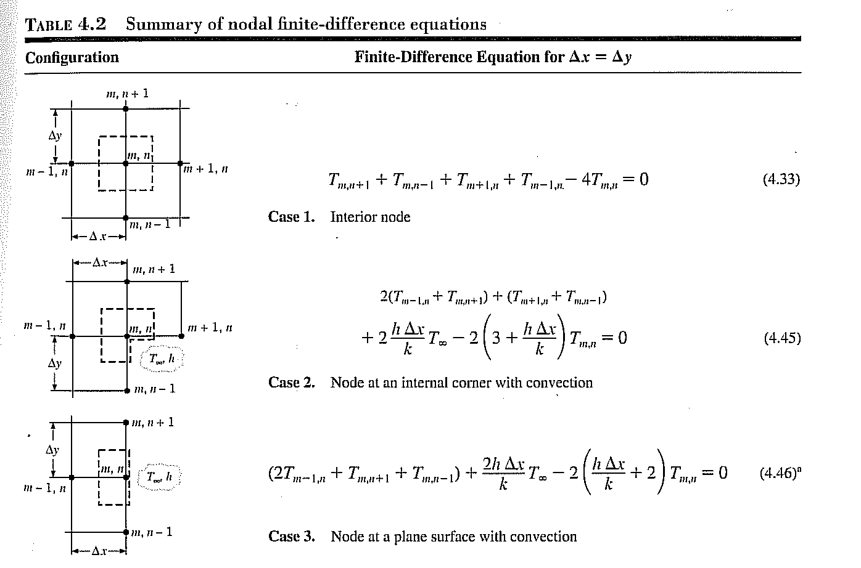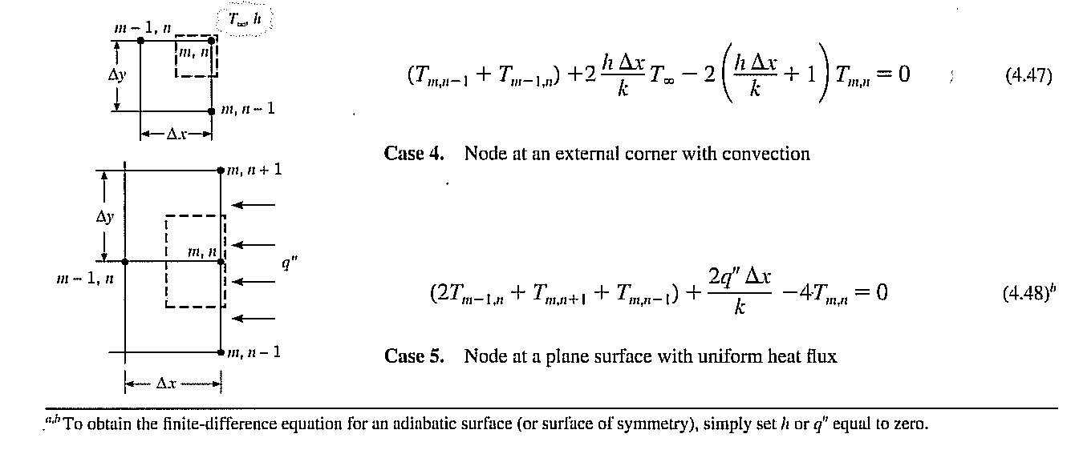
F. Incropera and D. DeWitt. 2001. Introduction to Heat Transfer. New York: John Wiley and Sons.

